Unit 3 Review 2

1.) If a 36-inch yardstick casts a 21-foot shadow, how tall is a building whose shadow is 168 ft?

2.) Are these triangles similar? How can you tell?
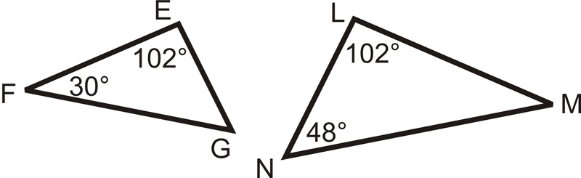

3.) Are these triangles similar? How can you tell?
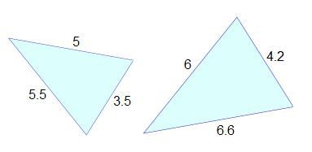
4.) Are these triangles similar? How can you tell?
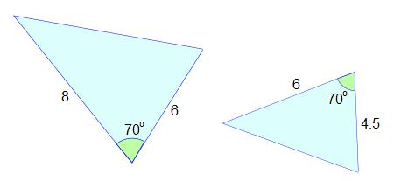

5.)
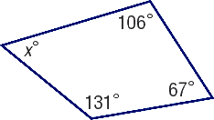
6.)
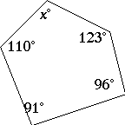
7.)
8.)
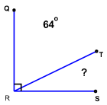
9.)
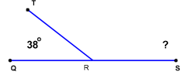

10.) If the measure of angle C is 62º, then what is the measure of angle H?

11.) If the measure of angle A is 124º, then what is the measure of Angle E?
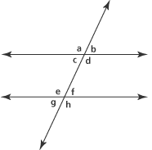

12.)
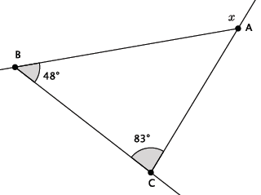

13.)

14.)

15.) Do the side lengths 12, 16, 20 form a right triangle? How can you tell?

