Unit 3 Review 1

1.) A map has a scale of 3 cm: 18 km. If Riverside and Smithville are 54 km apart, then how far apart are they on the map?

2.) Are the triangles below similar? How can you tell?
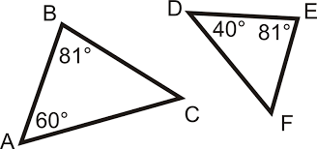

3.) Are the triangles below similar? How can you tell?
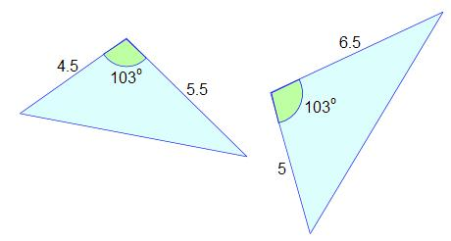
4.) Are the triangles below similar? How can you tell?
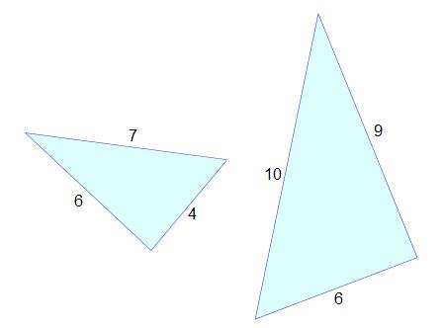

5.)
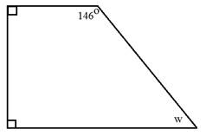
6.)
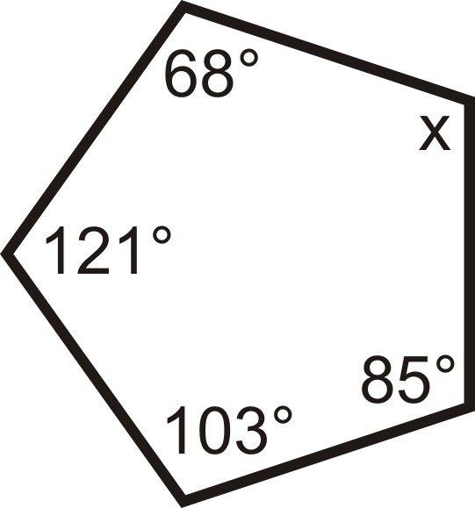
7.)
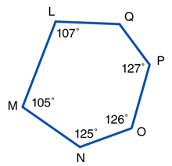
8.)
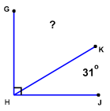
9.)
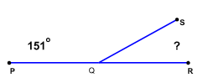

For questions 10-16, use the figure below.
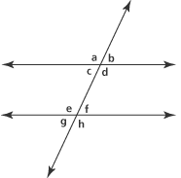
10.) Corresponding Angles

11.) Interior Angles

12.) Exterior Angles

13.) Alternate Interior Angles

14.) Alternate Exterior Angles

15.) If the measure of angle B is 54º, then what is the measure of angle G?

16.) If the measure of angle E is 107º, then what is the measure of angle F?

For questions 17-20, define each of the following vocabulary terms.

17.) Vertical Angles

19.) Complementary Angles

18.) Supplementary Angles

20.) Similar Figures

21.) Find the missing angle.
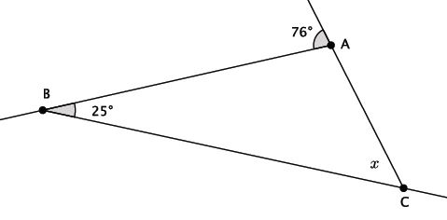
22.) Find the missing side length.
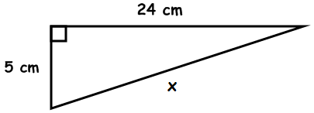
23.) Find the missing side length.
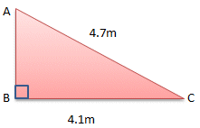
24.) Do the side lengths 10, 22, 26 form a right triangle? How can you tell?

