The square root of a number is a value that, when multiplied by itself, gives the number.
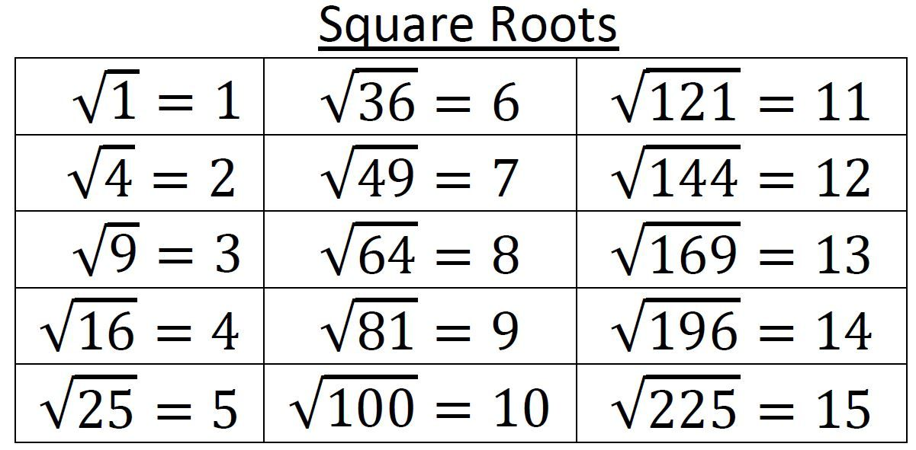

What two whole numbers does each square root fall between?
$\sqrt{99}$
Between 9 & 10
$$\sqrt{140}$$
Between 11 & 12

Find each square root to the nearest tenth:
$$\sqrt{37}$$
6.1
$$\sqrt{66}$$
8.1

Find each square root to the nearest hundredth:
$$\sqrt{220}$$
14.83
$$\sqrt{28}$$
5.29

Place the following numbers in their approximate location on the number line:
$$\sqrt{82}$$
$$\sqrt{50}$$
$$\sqrt{85.1}$$
$$\sqrt{60}$$
$$\sqrt{78}$$
$\sqrt{50}$ $\sqrt{60}$ $\sqrt{78}$ $\sqrt{82} \sqrt{85.1}$

Place the following numbers in their approximate location on the number line:
$$\sqrt{15.6}$$
$$\sqrt{23.5}$$
$$\sqrt{38.4}$$
$$\sqrt{13.5}$$
$$\sqrt{5}$$
$\sqrt{5}$ $\sqrt{13.5}\sqrt{15.6}$ $\sqrt{23.5}$ $\sqrt{38.4}$

Place the following numbers in their approximate location on the number line:
$$\sqrt{162}$$
$$\sqrt{144}$$
$$\sqrt{125}$$
$$\sqrt{214}$$
$$\sqrt{170}$$
$\sqrt{125}$ $\sqrt{144}$ $\sqrt{162}$ $\sqrt{170}$ $\sqrt{214}$
The cube root of a number is a value that, when multiplied three times, gives the number.

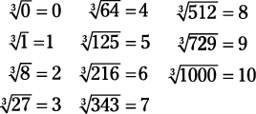

What two whole numbers does each cube root fall between?
$$\sqrt[3]{37}$$
Between 3 & 4
$$\sqrt[3]{785}$$
Between 9 & 10

Find each cube root to the nearest thousandth:
$$\sqrt[3]{302}$$
6.709
$$\sqrt[3]{12}$$
2.289

Find each cube root to the nearest tenth:
$$\sqrt[3]{645}$$
8.6
$$\sqrt[3]{157}$$
5.4

Place the following numbers in their approximate location on the number line:
$$\sqrt[3]{216}$$
$$\sqrt[3]{79}$$
$$\sqrt[3]{154}$$
$$\sqrt[3]{42}$$
$\sqrt[3]{42}$ $\sqrt[3]{79}$ $\sqrt[3]{154}$ $\sqrt[3]{216}$

Place the following numbers in their approximate location on the number line:
$$\sqrt[3]{675}$$
$$\sqrt[3]{901}$$
$$\sqrt[3]{729}$$
$$\sqrt[3]{856}$$
$\sqrt[3]{675}$ $\sqrt[3]{729}$ $\sqrt[3]{856}$ $\sqrt[3]{901}$

Place the following numbers in their approximate location on the number line:
$$\sqrt[3]{52}$$
$$\sqrt[3]{100}$$
$$\sqrt[3]{17}$$
$$\sqrt[3]{234}$$
$\sqrt[3]{17}$ $\sqrt[3]{52}$ $\sqrt[3]{100}$ $\sqrt[3]{234}$

