Unit 5 Lesson 9 – Modeling Linear Relationships
1.) One site offers MP3 downloads of individual songs with the following price structure: a $\$3$ fixed fee for monthly subscription PLUS a charge of $\$0.25$ per song.
a.) Using $x$ for the number of songs downloaded and $y$ for the total monthly cost, construct a linear function to model the relationship between the number of songs downloaded and the total monthly cost.

b.) Construct a table to record the total monthly cost (in dollars) for MP3 downloads of $10$songs, $20$songs, and so on up to $100$songs.
Songs | Price
10
20
30
40
50
60
70
80
90
100

2.) A band will be paid a flat fee for playing a concert. The band will receive a fixed amount for every ticket sold. If $40$ tickets are sold, the band will be paid $\$200$. If $70$tickets are sold, the band will be paid $\$260$.
a.) Write a linear function to model the relationship between the number of tickets sold and the total cost.

b.) Construct a table to record the total cost of 10 tickets, 20 tickets, and so on, up to 100 tickets.
Tickets | Cost
10
20
30
40
50
60
70
80
90
100

3.) Suppose that the price of gasoline has been falling. At the beginning of last month ($t=0$), the price was $\$4.60$ per gallon. Twenty days later ($t=20$), the price was $\$4.20$ per gallon. Assume that the price per gallon, $P$, fell at a constant rate over the twenty days.

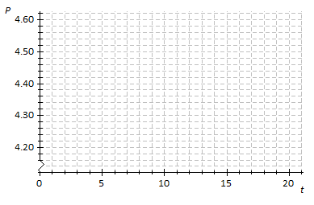
Price per Gallon
Time in Days

a.) Identify the ordered pairs given in the problem. Plot both points on the coordinate plane above. Using a straight-edge, draw the line that contains the two points.

b.) What is the rate of change? What does it mean within the context of the problem?

c.) What is the function that models the relationship between the number of days and the price per gallon?

d.) What was the price of gasoline after $9$days?

e.) After how many days was the price $\$4.32$?

4.) An online bookseller has a new book in print. The company estimates that if the book is priced at $15, then 800 copies of the book will be sold per day, and if the book is priced at $\$20$, then $550$copies of the book will be sold per day.
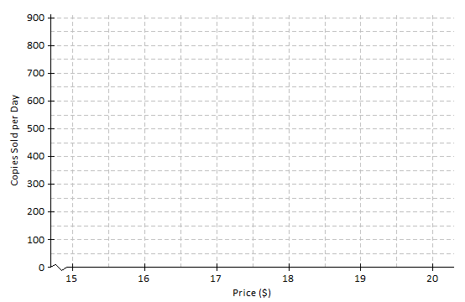
a.) Identify the ordered pairs given in the problem. Then, plot both on the graph. Using a straight-edge, draw the line that passes through the two points.

b.) What is the rate of change relating number of copies sold to price?

c.) Based on the graph, if the company prices the book at $\$18$, about how many copies of the book can they expect to sell per day?

d.) Based on the graph, approximately what price should the company charge in order to sell $700$copies of the book per day?

