A painter has been paid a fee of $1,200 and will additionally receive $2.50 for every painting that is sold.

a.) Sketch the graph of the linear function that relates the total amount of money earned, A, to the number of paintings sold, n, on the axes below.

Number of books sold
Total Amount of Money Earned

Number of Paintings Sold

b.) What is the rate of change that relates the total amount of money earned to the number of paintings sold?
2.50
c.) What is the initial value of the linear function based on the graph?
1200

d.) Let the number of paintings sold be n and the total amount earned be A. Construct a linear function that models the relationship between the number of books sold and the total amount earned.

A = 2.50n + 1200

A car rental company charges a $50 rental fee in addition to a charge of $1.50 per mile driven.

a.) On the axes given, sketch the graph of the linear function that relates C to m.
Cost ($\$$)
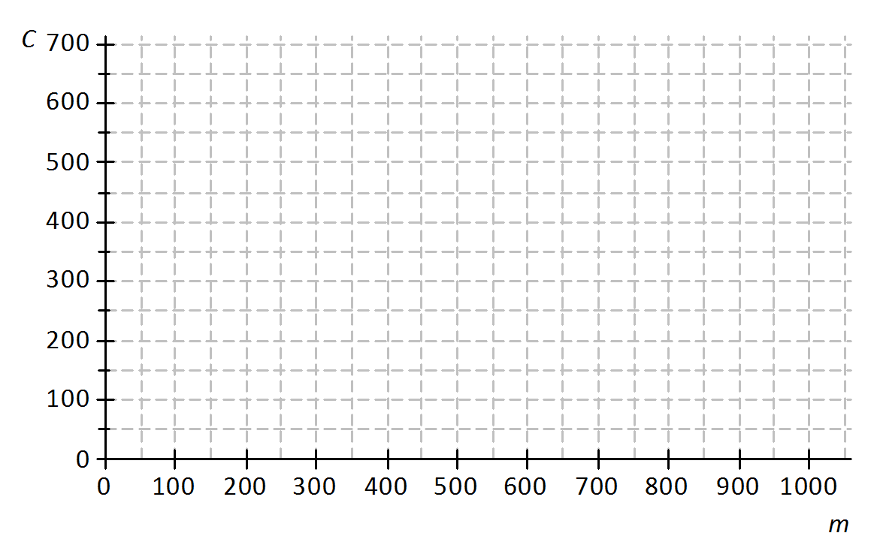
b.) If the car is driven 0 miles, what will be the cost to the customer? How will this be shown on the graph?
Miles

$50 – The starting value.

c.) What is the rate of change that relates cost to number of miles driven? Explain what it means within the context of the problem.

$1.50 – It costs $1.50 for every mile driven.

d.) Write the equation of the linear function that models the relationship between number of miles driven and total rental cost.

C = 1.50m + 50

Sara bought a used car for $20,000 and the value of the car is likely to decrease by $1,500 for each year that she owns the car.

a.) On the axes below, sketch a graph of the linear function that relates V to t.

Value of the Car in Dollars
Number of Years

b.) What is the rate of change that relates V to t? (Is it positive or negative? How can you tell?)

-1500 – It is negative because the value of the car is decreasing.

c.) Find the value of the car when

t = 1 $18,500

t = 3 $15,500

t = 6 $11,000

d.) Write the linear function that models the relationship between the number of years Sara has owned the car and the value of the car.

V = -1,500t + 20,000

A mechanic charges a service fee of $100 plus $20 for each hour worked.

a.) On the axes below, sketch a graph that relates C to t.
Cost in Dollars
Time in Hours

b.) If the mechanic works for $0$ hours, what will be the cost to the customer? How will this be shown on the graph?
$100 – This is the starting value.

c.) What is the rate of change that relates cost to time?

$20

d.) Write a linear function that models the relationship between the hours worked and cost to the customer.

C = 20t + 100

e.) Find the cost to the customer if the mechanic works for each of the following number of hours.

2 hours $140

3 hours $160

7 hours s$240

