Unit 5 Lesson 5 – Graphs of Proportional Relationships
Sally earns $8.00 per hour working as a babysitter. On the axes provided, sketch a graph that represents the proportional relationship. Provide a scale, label the axes, write an equation and title the graph.
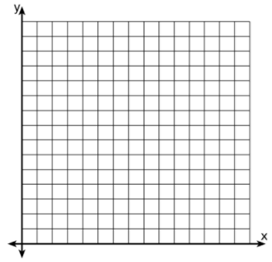

A caterer charges $22 per person providing food and services at a graduation party. On the axes provided, sketch a graph that represents the proportional relationship for a maximum of 10 guests. Provide a scale, label the axes, write an equation and title the graph.
Three Ida Red apples cost $2.25. On the axes provided, sketch a graph that represents the proportional relationship for the purchase of a maximum of 10 apples. Provide a scale, label the axes, write an equation and title the graph.

At an airport currency exchange, 4 U.S. dollars is equivalent to 2.66 British pounds. On the axes provided, sketch a graph that represents the proportional relationship. Provide a scale, label the axes, write an equation and title the graph.
Joe’s Pizza sells cheese pizza for $1.75 per slice. On the axes provided, sketch a graph that represents the proportional relationship for a maximum of 5 slices. Provide a scale, label the axes, write an equation and title the graph.

Water flows into a tank at a rate of 5 gallons each half hour. On the axes provided, sketch a graph that represents the proportional relationship. Provide a scale, label the axes, write an equation and title the graph.

