A maple tree grows 10 inches each year. On the axes provided, sketch a graph that represents the proportional relationship. Provide a scale, label the axes, write an equation and title the graph.
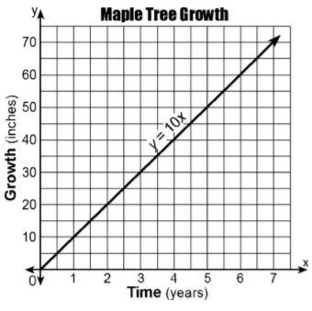
A baker makes 5 cakes every 2 hours. On the axes provided, sketch a graph that represents the proportional relationship for 8 hours of baking. Provide a scale, label the axes, write an equation and title the graph.
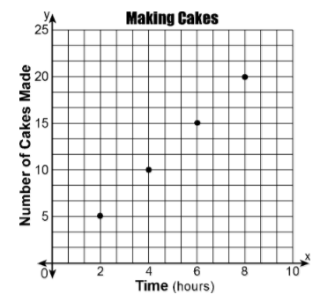
At an airport currency exchange, 5 U.S. dollars is equivalent to 4 euros. On the axes provided, sketch a graph that represents the proportional relationship. Provide a scale, label the axes, write an equation and title the graph.
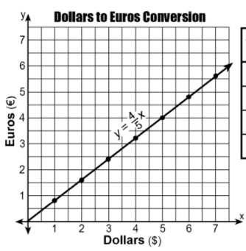
Mrs. Jones grades 7 exams every 1.5 hours. On the axes provided, sketch a graph that represents the proportional relationship. Provide a scale, label the axes, write an equation and title the graph.
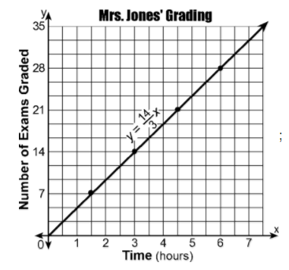

Every three days, Juan buys 10 gallons of gasoline. On the axes provided, sketch a graph that represents the proportional relationship for a 15 day period. Provide a scale, label the axes, write an equation and title the graph.
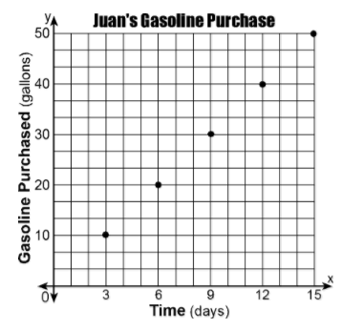
Alice rides her bike at 9 miles per hour. On the axes provided, sketch a graph that represents the proportional relationship. Provide a scale, label the axes, write an equation and title the graph.
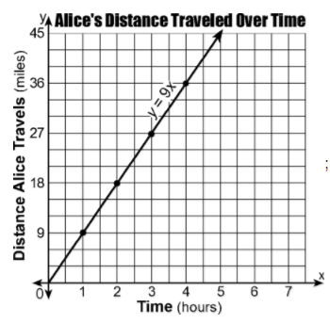

Gasoline costs $4.12 per gallon. On the axes provided, sketch a graph that represents the proportional relationship. Provide a scale, label the axes, write an equation and title the graph.
