In the function y = 4x + 6, what is the output value, y, when the input value is x = 2?
y = 4(2) + 6
y = 8 + 6
y = 14

In the function y = -3x + 5, what is the output value, y, when the input value is x = 1?
y = -3(1) + 5
y = -3 + 5
y = 2

In the function 5x + y = 8, what is the input value, x, when the output value is y = 3?
5x + 3 = 8
-3 -3
5x = 5
5 5
x = 1

In the linear function y = -4x + 3, if x = 2, then find the value of y.
y = -4(2) + 3
y = -8 + 3
y = -5

In the linear function y = 3x + 8, if y = 17, find the value of x.
17 = 3x + 8
-8 -8
9 = 3x
3 3
3 = x

In the function 2x – y = 12, if x = 6, find the value of y.
2(6) – y = 12
12 – y = 12
-12 -12
-y = 0
-1 -1
y = 0

What are the missing input and output values in the table below for the function x + y = 7?
x | y
 | 3
3
 | 7
-1

x | y
4 | 3
3 | 4
0 | 7
-1 | 8

What are the missing input and output values in the table below for the function 2x + y = 6?
x | y
 | 6
2
3
 | -2

x | y
0 | 6
2 | 2
3 | 0
4 | -2

What are the missing input and output values in the table below for the function 3y – 2x = 9?
x | y
6
 | 5
0
 | 1

x | y
6 | 7
3 | 5
0 | 3
-3 | 1

What are the missing input and output values in the table below for the function 2x – y = 4?
x | y
 | 6
3
0
 | -6

x | y
5 | 6
3 | 2
0 | -4
-1 | -6

For the linear function 4x – y = -2, complete the table of values below.
x | y
2
 | 2
 | -2
-3

x
2 | 10
0 | 2
-1 | -2
-3 | -10

Use the graph of the function below to determine the corresponding input value for an output value of 4.
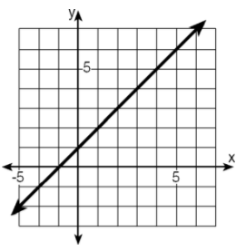
3
Use the graph of the function below to determine the corresponding input value for an output value of 0.
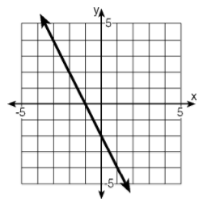
-1
Use the graph of the function below to determine the corresponding input value for an output value of -2.
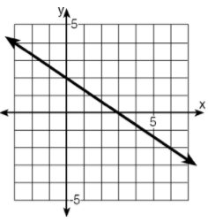
6
Using the graph of the linear function below, find the corresponding input value when the output value is 3.
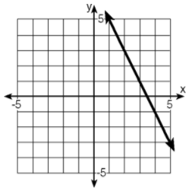
2
Using the graph of the linear function below, find the corresponding input value when the output value is 4.
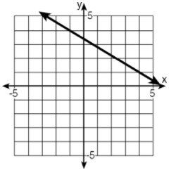
-1
Use the graph of the function below to determine the corresponding input value for an output value of 1.
0
Use the graph of the function below to determine the corresponding input value for an output value of -2.
6

