Unit 5 Lesson 2 – Input and Output

1.) In the function y = -2x – 4, what is the output value, y, when the input value is x = -2?

2.) In the function y = 2x – 5, what is the input value, x, when the output value is y = 7?

3.) In the function y = 5x – 4, if x = 6, find the value of y.

4.) In the function y = 10 – x, if y = 7, find the value of x.

5.) What are the missing input and output values in the table below for the function x + 2y = 8?

x | y
6
 | 3
 | 4
-4

6.) Use the graph of the function below to determine the corresponding output value for an input value of 4.

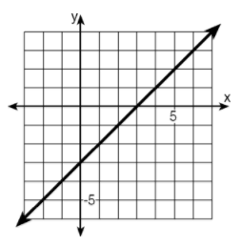
7.) Use the graph of the function below to determine the corresponding output value for an input value of 2.

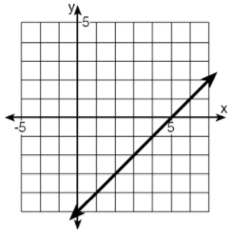

8.) Using the graph of the function below, find the corresponding input value for an output value of 3.

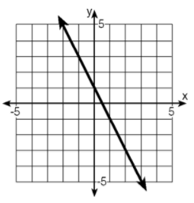

9.) Using the graph of the linear function below, find the corresponding input value when the output value is -2.

