Function – Every input has exactly one output. (Each x-value only has only y-value.)
x | 1 | 2 | 3 | 4 | 5
y | 2 | 7 | 3 | 8 | 9
Function because the x-values do not repeat.
x | 1 | 4 | 6 | 1 | 8
y | 2 | 4 | 9 | 5 | 1
Not a function because 1 has outputs of 2 and 5.
x | 1 | 2 | 3 | 3 | 6
y | 4 | 5 | 6 | 6 | 7
Function because 3 has the same exact output.
x | 1 | 2 | 3 | 4 | 5
y | 1 | 1 | 1 | 1 | 1
Function because the x-values do not repeat.
x | 2 | 2 | 2 | 2 | 2
y | 4 | 4 | 4 | 4 | 4
Function because all of the inputs have the exact same output.
x | 1 | 2 | 3 | 1 | 2
y | 4 | 5 | 4 | 6 | 5
Not a function because 1 has inputs of 4 and 6.
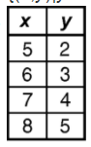
Function because the x-values do not repeat.

Not a function because 3 has outputs of 54 and 84.
{(1, 3), (2, 7), (1, -2)}
Not a function because 1 has outputs of 3 and -2.
{(1, 1), (2, 1), (3, 1)}
Function because the x-values do not repeat.
{(3, 2), (5, 3), (5, 5)}
Not a function because 5 has outputs of 3 and 5.
{(1. 4), (3, 8), (5, 16)}
Function because the x-values do not repeat.
{(1, 1), (2, 2), (3, 3)}
Function because the x-values do not repeat.
{(1, 1), (1, 2), (1, 3)}
Not a function because 1 has outputs of 1, 2 and 3.
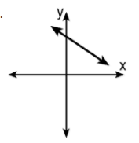

Function because it passes the vertical line test.
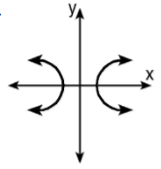
Not a function because it does not pass the vertical line test.
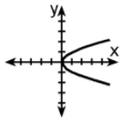
Not a function because it does not pass the vertical line test.
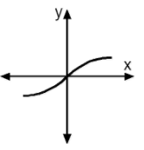
Function because it passes the vertical line test.
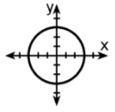
Not a function because it does not pass the vertical line test.

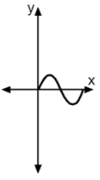
Function because it passes the vertical line test.
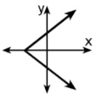
Not a function because it does not pass the vertical line test.
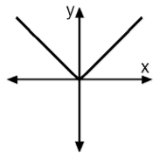
Function because it passes the vertical line test.
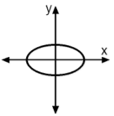
Not a function because it does not pass the vertical line test.

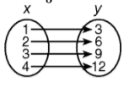
Function because every input has one output.
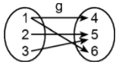
Not a function because 1 has outputs of 4 and 6.
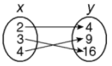
Function because every input has one output.
Function because every input has one output.
Not a function because a has outputs of p and r and b has outputs of p and r.

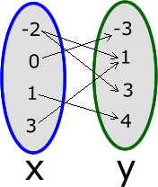
Not a function because -2 has outputs of 1 and 3.
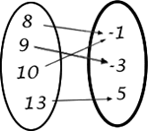
Function because every input has one output.
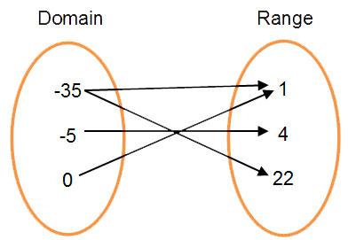
Not a function because -35 has outputs of 1 and 22.

