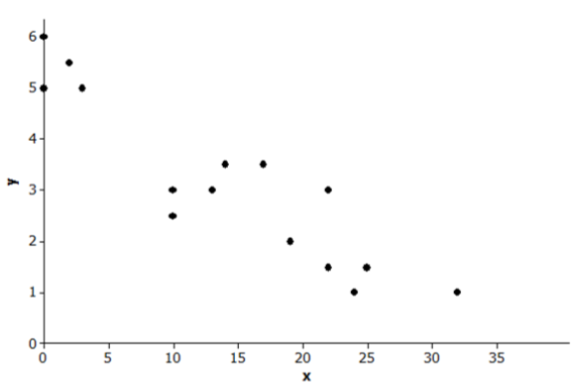
1.) Is there a relationship? Yes
2.) If there is a relationship, is it linear or non-linear? Linear
3.) If there is a relationship, is it increasing or decreasing? Decreasing
4.) If there is a relationship, is it weak or strong? Strong

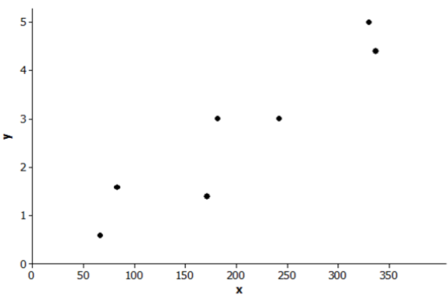
1.) Is there a relationship? Yes
2.) If there is a relationship, is it linear or non-linear? Linear
3.) If there is a relationship, is it positive or negative? Positive
4.) If there is a relationship, is it weak or strong? Strong

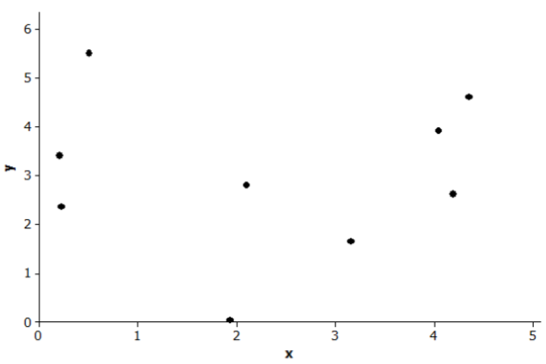
1.) Is there a relationship? No
2.) If there is a relationship, is it linear or non-linear?
3.) If there is a relationship, is it increasing or decreasing?
4.) If there is a relationship, is it weak or strong?

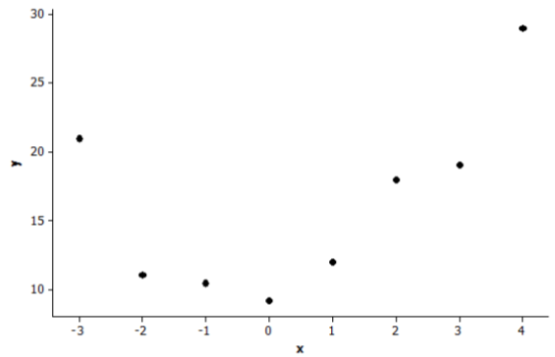
1.) Is there a relationship? Yes
2.) If there is a relationship, is it linear or non-linear? Non-Linear
3.) If there is a relationship, is it positive or negative? Neither
4.) If there is a relationship, is it weak or strong? Strong
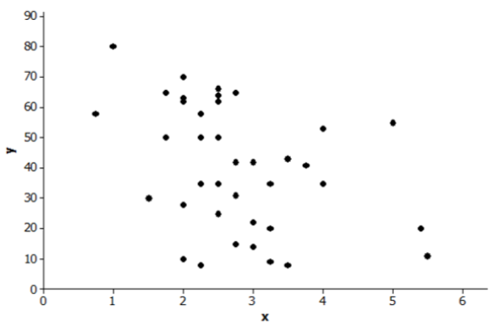
1.) Is there a relationship? No
2.) If there is a relationship, is it linear or non-linear?
3.) If there is a relationship, is it positive or negative?
4.) If there is a relationship, is it weak or strong?

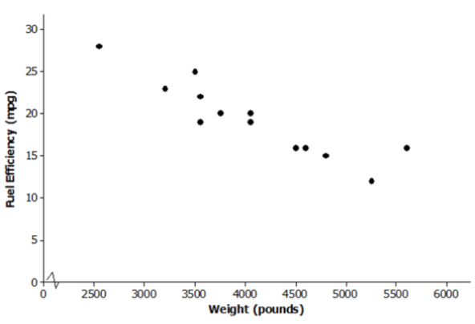
Describe the relationship, if any, between fuel efficiency and weight of the car.
Fuel efficiency goes down as the weight of the car increases.

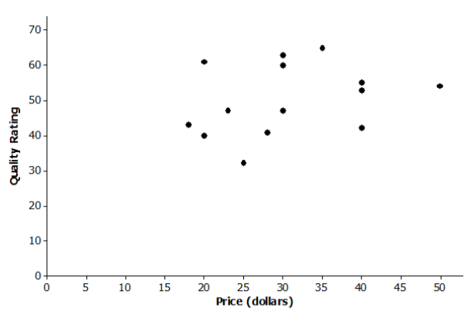
Describe the relationship, if any, between quality of bike helmets and cost of bike helmets.
There does not seem to be a relationship between quality of bike helmets and cost of bike helmets.

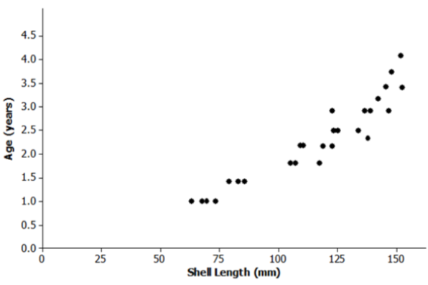
Describe the relationship, if any, between lobster age and shell length.
As the lobster gets older, the shell length gets longer.

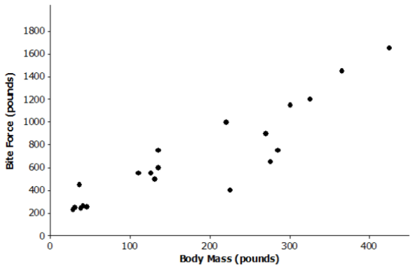
Describe the relationship, if any, between body mass and bite force of a crocodile.
The bite force of a crocodile gets stronger as the body mass increases.

Clusters: A group of points in a scatter plot that are close together.

Outlier: A point or a couple of points that are far away from the other points.

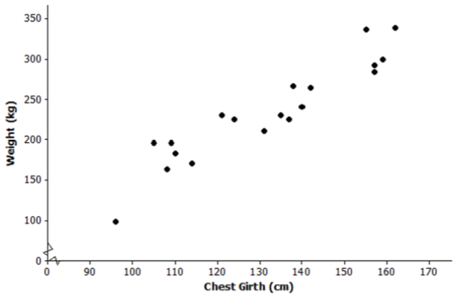
This scatter plot shows the weight of an Elk and the chest girth. Are there any clusters or outliers shown? What does it mean if there are?
The first point could be considered an outlier. Most of the Elks have a chest girth over 100 cm and a weight of over 150 kg so the first Elk is smaller than the others. There are several clusters, which means that Elks that are close in weight usually have a similar chest girth.

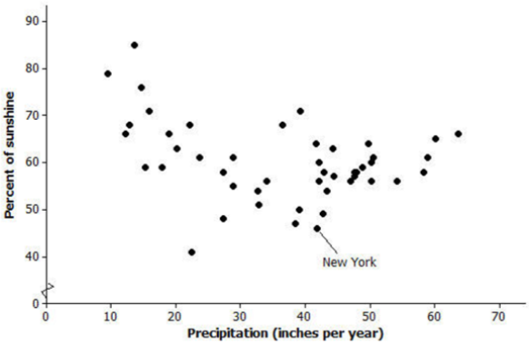
This scatter plot shows percent of sunshine and precipitation (inches per year) for all 50 states. Are there any clusters or outliers shown? What does it mean if there are?
There are some clusters, which means that states that have a similar percent of sunshine also have a similar amount of inches of precipitation each year.

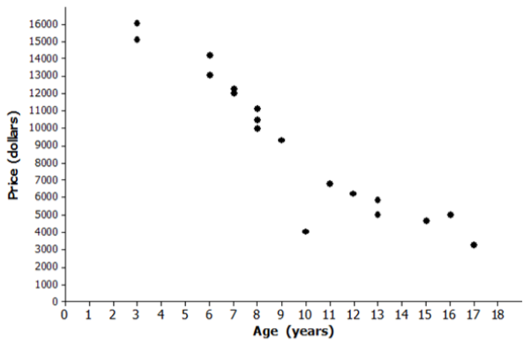
This scatter plot shows the age of a car and its price value. Are there any clusters or outliers shown? What does it mean if there are?
There are some clusters, which mean that the cars that are the same age have a similar price value. There is an outlier for a 10 year old car. That car might be worth less because it was in an accident or is in worse shape than the other cars.

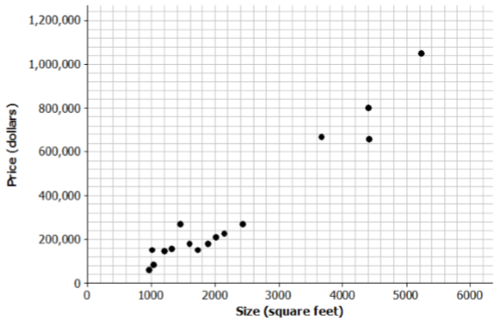
What is the size estimate of a $600,000 house?
About 3,000 square feet

What is the prediction of price of a 1,500 square foot house?
About $175,000

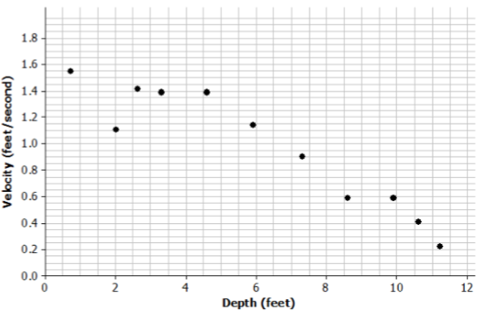
If the river is 2 feet deep, how fast do you think the current would be?
About 1.4 feet/second

If the velocity is 0.8 feet/second, how deep do you think the water is?
About 8 feet

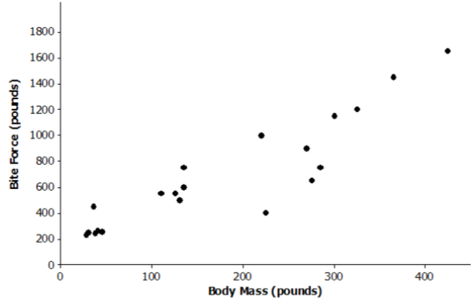
Predict the bite force for a crocodile that weighs 220 pounds.
About 400 pounds

Predict the body mass for a crocodile that has a bite force of 1000 pounds.
About 250 pounds

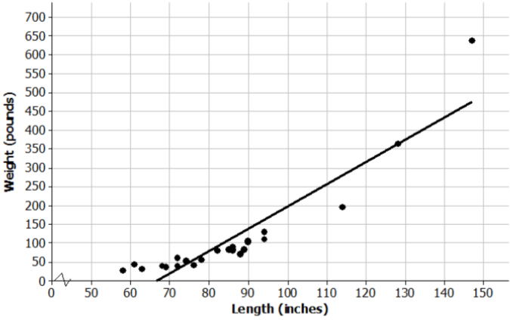
Scientists captured a small sample of alligators and measured both their length (in inches) and weight (in pounds). Torre used their data to create the following scatter plot and drew a line to capture the trend in the data. She and Steve then had a discussion about the way the line fit the data. What do you think they were discussing and why?
The line of best fit should have been non-linear because the points do not fall into a straight line.
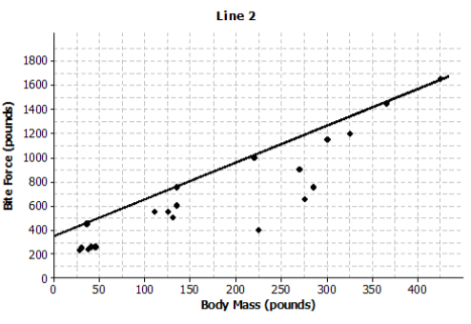
The scatter plots show different lines that students used to model the relationship between body mass (in pounds) and bite force (in pounds) for crocodilian. Do you think that the line that this student drew is a line of best fit? Why or why not?
This is not a good line of best fit because most of the points fall below the line.

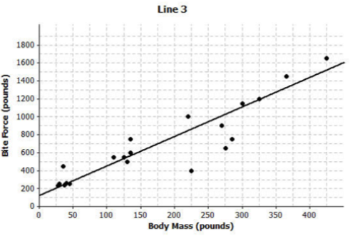
The scatter plots show different lines that students used to model the relationship between body mass (in pounds) and bite force (in pounds) for crocodilian. Do you think that the line that this student drew is a line of best fit? Why or why not?
This is a good line of best fit because some points are on the line, some points are above the line and some points are below the line. This student did a pretty good job drawing the line that fit the points.

