The chart below shows the number of hours six men and women on a diet walked each week for eight weeks and the number of pounds each lost at the end of those eight weeks. Create a scatter plot of this data and draw a line of best fit.
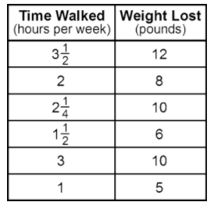
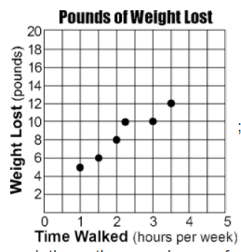
Estimate how much weight you would lost if you walked 4 hours per week.
Around 14 pounds

Estimate how long you would have to walk to lose 7 pounds.
About 1.5 hours

For a botany class project, Robert wonders if there is a connection between the size of a watermelon and the depth of its roots. Eight watermelon vines are chosen at random and, at the end of 7 weeks, the watermelons and their roots are measured. Draw a scatter plot of this data and draw a line of best fit.
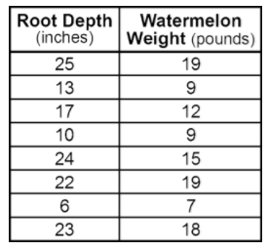
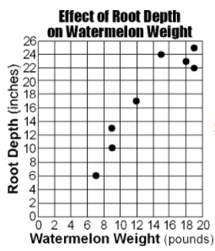
Estimate the root depth of a watermelon that weighs 16 pounds.
About 20 inches

Estimate the weight of a watermelon that has a root depth of 4 inches.
About 4 pounds

In the summertime, crickets will chirp more often as the temperature rises. It is almost possible to use the crickets as a thermometer. A Harvard professor, George Pierce, made a detailed study of this phenomenon. The chart below shows his findings. Draw a scatter plot of this data and draw a line of best fit.
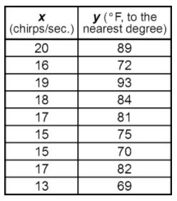

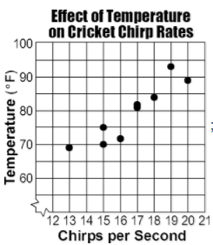
Estimate the number of cricket chirps there would be if it was 90ºF.
About 19 chirps

Estimate the temperature when there are 14 cricket chirps.
About 70ºF
A car dealership has been running television ads during the evening hours that advertise the different models and price ranges of the cars on the lots that week. For six weeks, the dealership kept a weekly record of the number of ads run and the number of cars sold. Create a scatter plot of this data and draw a line of best fit.
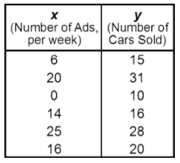
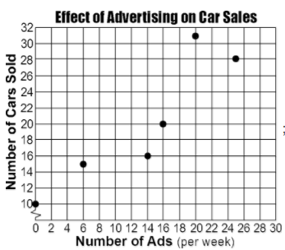
Estimate the number of cars sold if there are 10 ads in a week.
About 18 cars

Estimate the number of ads in a week if 24 cars are sold.
About 18 ads

