Unit 5 Lesson 13 – Line of Best Fit
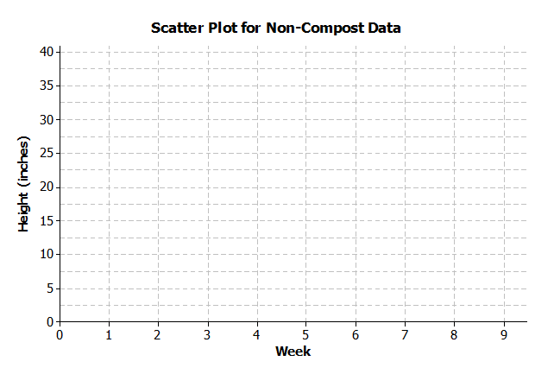
1.) A group of students wanted to find whether or not compost is beneficial in plant growth. They found the median growth height for each group of eight plants. The table below shows the results of the experiment for the dahlias grown in non-compost beds. On the grid below, construct a scatter plot and draw a line of best fit.
Week | Median Height in Non-Compost Bed (inches)
$$1$$ | $$9.00$$
$$2$$ | $$12.75$$
$$3$$ | $$16.25$$
$$4$$ | $$19.50$$
$$5$$ | $$23.00$$
$$6$$ | $$26.75$$
$$7$$ | $$30.00$$
$$8$$ | $$33.75$$
$$9$$ | $$37.25$$

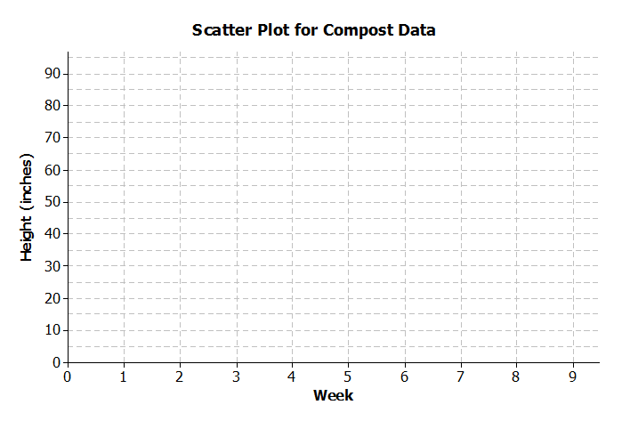
2.) The table below shows the results of the experiment for the dahlias grown in compost beds. On the grid below, construct a scatter plot and draw a curve of best fit. (This is a non-linear example.)
Week | Median Height in  Compost Bed (inches)
$$1$$ | $$10.00$$
$$2$$ | $$13.50$$
$$3$$ | $$17.75$$
$$4$$ | $$21.50$$
$$5$$ | $$30.50$$
$$6$$ | $$40.50$$
$$7$$ | $$65.00$$
$$8$$ | $$80.50$$
$$9$$ | $$91.50$$

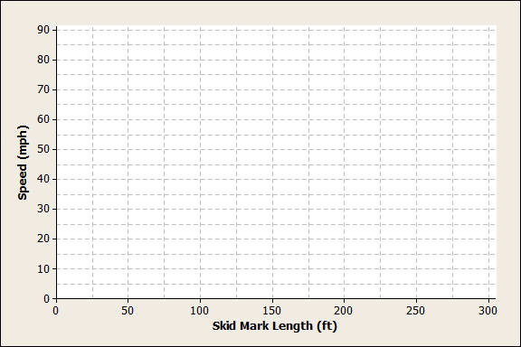
3.) When there is a car accident, investigators determine the speed of the cars involved by measuring the skid marks left by the car. The table below shows data collected from an experiment with a test car. Construct a scatter plot and draw either a line of best fit or curve of best fit.
Skid-Mark Length ($ft.$) | Speed ($mph$)
$$5$$ | $$10$$
$$17$$ | $$20$$
$$65$$ | $$40$$
$$105$$ | $$50$$
$$205$$ | $$70$$
$$265$$ | $$80$$

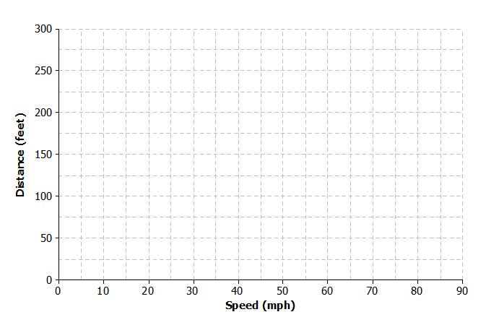
4.) Once the brakes of the car have been applied, the car does not stop immediately. The distance that the car travels after the brakes have been applied is called the braking distance. The table below shows braking distance (how far the car travels once the brakes have been applied) and the speed of the car. Construct a scatterplot and draw a curve or line of best fit.
Speed ($mph$) | Distance Until Car Stops ($ft.$)
$$10$$ | $$5$$
$$20$$ | $$17$$
$$30$$ | $$37$$
$$40$$ | $$65$$
$$50$$ | $$105$$
$$60$$ | $$150$$
$$70$$ | $$205$$
80 | 265

a.) Estimate braking distance for a car traveling at $52 mph$.

b.) Estimate braking distance for a car traveling at $75 mph$.

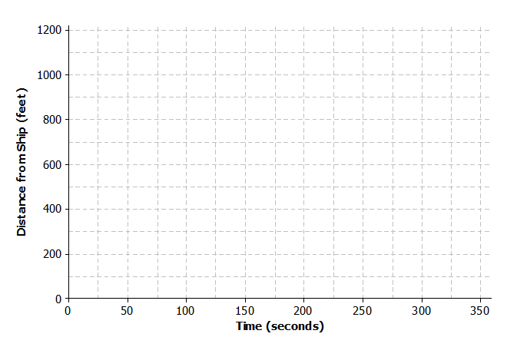
5.) A dolphin is fitted with a GPS system that monitors its position in relationship to a research ship. The table below contains the time (in seconds) after the dolphin is released from the ship and the distance (in feet) the dolphin is from the research ship. Construct a scatter plot and draw a line or curve of best fit.
Time ($sec.$) | Distance from Ship ($ft.$)
$$0$$ | $$0$$
$$50$$ | $$85$$
$$100$$ | $$190$$
$$150$$ | $$398$$
$$200$$ | $$577$$
$$250$$ | $$853$$
$$300$$ | $$1,122$$

a.) Estimate how far the dolphin will be from the ship after $180$ seconds.

b.) Estimate how many seconds it will take the dolphin to be 1,000 feet from the ship.

