Unit 5 Lesson 12 – Constructing Scatter Plots
1.) Two different tests were given to measure students’ understanding of a certain topic. The tests were given to seven students, and the results are shown below. Construct a scatter plot for these scores.
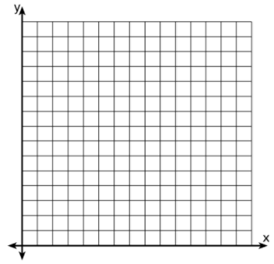
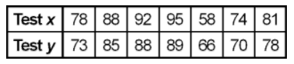

2.) The data for 12 students’ math grades and their weight in pounds is recorded in the accompanying table. Construct a scatter plot for the given data.
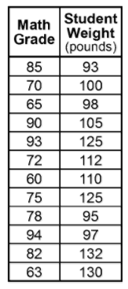
3.) A large industrial plant studies the relationship between the number of hours devoted to safety training and the number of work hours lost due to workplace accidents. Use this data to create a scatter diagram.
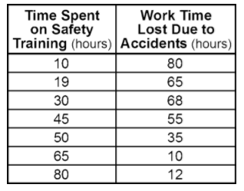

4.) The chart below shows the number of hours 6 students spent studying for a Biology test and the grade they received on that test. Use this data to create a scatter plot.
