The data for 10 students’ science grades and the distance, in miles, that each student lives from the school are recorded in the accompanying table. Construct a scatter plot for the given data.
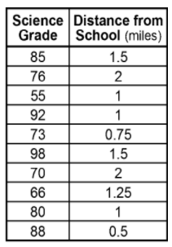
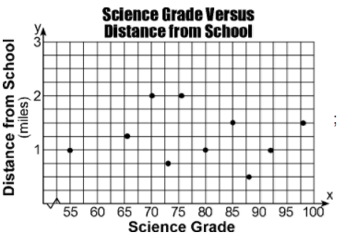

A teacher gave two grades to her students for the first school quarter. The first grade, x, was each student’s homework grade, and the second grade, y, was the student’s test and quiz average. The data from eight of her students is shown in the chart below. Use this data to create a scatter plot.
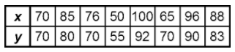
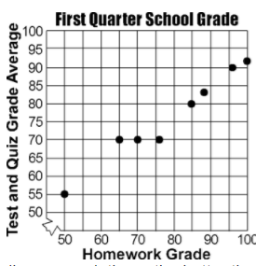

The chart below represents the weight, in hundreds of pounds, of seven vehicles and the gas mileage each vehicle gets. Make a scatter diagram of this data.
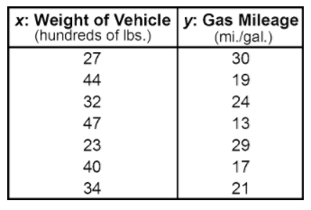
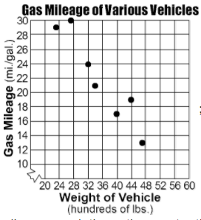

A principal at Gamma High School wanted to see if there is a relationship between a student’s IQ (x) and his/her GPA (y). He chooses 10 students from the senior class at random. Create a scatter plot of this data.
