Sketch a graph of a function that models the situation. A messenger service charges a flat rate of $4.95 to deliver a package regardless of distance to the destination.
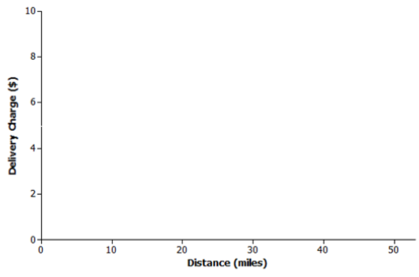
Sketch a graph of a function that models the situation. At sea level, the air that surrounds us presses down on our bodies at 14.7 pounds per square inch (psi). For every 10 meters that you dive under water, the pressure increases by 14.7 psi.
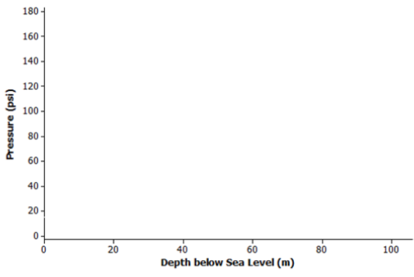

Sketch a graph of a function that models the situation. The range (driving distance per charge) of an electric car varies based on the average speed the car is driven. The initial range of the electric car after a full charge is 400 miles. However, the range is reduced by 20 miles for every 10 mph increase in average speed the car is driven.
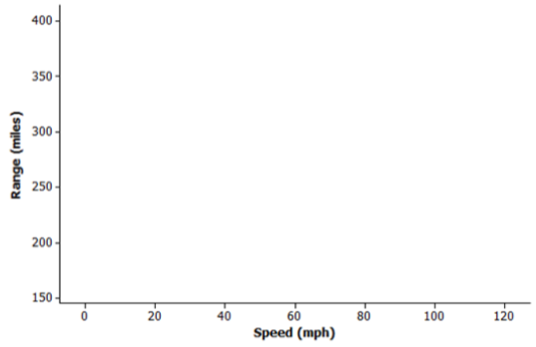
a.) A bathtub is filled at a constant rate of 1.75 gallons per minute.
b.) A bathtub is drained at a constant rate of 2.5 gallons per minute.
c.) A bathtub contains 2.5 gallons of water.
d.) A bathtub is filled at a constant rate of 2.5 gallons per minute.
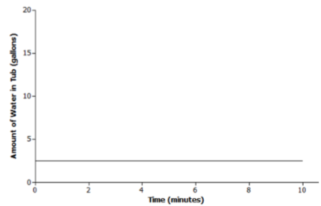

a.) A bathtub is filled at a constant rate of 1.75 gallons per minute.
b.) A bathtub is drained at a constant rate of 2.5 gallons per minute.
c.) A bathtub contains 2.5 gallons of water.
d.) A bathtub is filled at a constant rate of 2.5 gallons per minute.
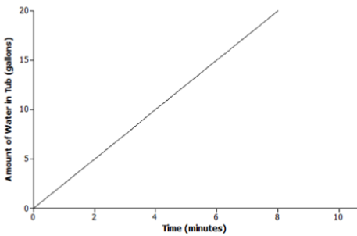

a.) A bathtub is filled at a constant rate of 1.75 gallons per minute.
b.) A bathtub is drained at a constant rate of 2.5 gallons per minute.
c.) A bathtub contains 2.5 gallons of water.
d.) A bathtub is filled at a constant rate of 2.5 gallons per minute.
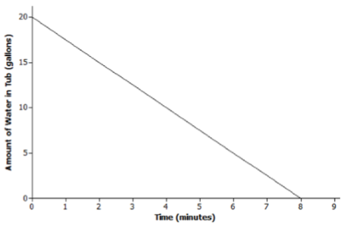

a.) A bathtub is filled at a constant rate of 1.75 gallons per minute.
b.) A bathtub is drained at a constant rate of 2.5 gallons per minute.
c.) A bathtub contains 2.5 gallons of water.
d.) A bathtub is filled at a constant rate of 2.5 gallons per minute.
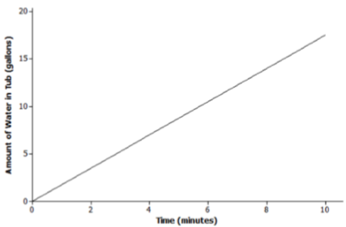

The graph below represents the total number of smart phones that are shipped to a retail store over the course of 50 days. Match each part of the graph (A, B, and C) to its verbal description. Explain the reasoning behind your choice.
i. Half of the factory workers went on strike, and not enough smartphones were produced for normal shipments.
C – The slope of the line is increasing, but at a slower rate than part A.
ii. The production schedule was normal, and smartphones were shipped to the retail store at a constant rate.
A – The slope of the line is increasing.
iii. A defective electronic chip was found, and the factory had to shut down; so, no smartphones were shipped.
B – The slope of the line is not increasing or decreasing and B has a constant slope.

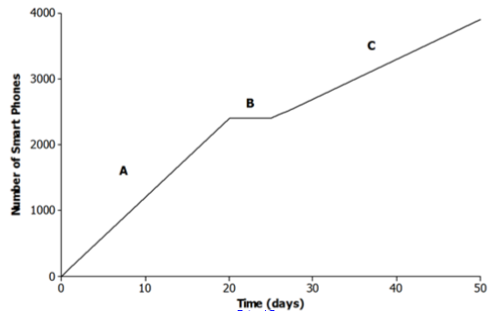

The relationship between Jameson’s account balance and time is modeled by the graph below.
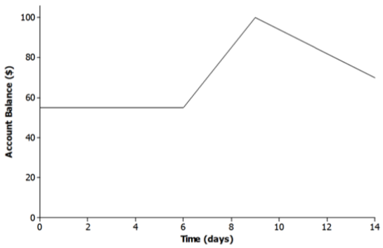
When is the function increasing? What could explain why it is increasing in this particular problem?
It is increasing from days 6 – 9. Money was probably added to the account.

When is the function decreasing? What could explain why it is decreasing in this particular problem?
It is decreasing from days 9 – 14. Money was probably taken out of the account.

When is the function constant? What could explain why it remains constant in this particular problem?

It is constant from days 0 – 6. No money was put in or taken out of the account.

Snow is falling at a rate of one foot an hour on top of a base 3 feet deep. Which of the following graphs best represents the relationship between the depth of the snow on the ground and the amount of time that has passed?

a.)
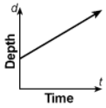
b.)
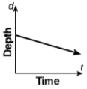
c.)
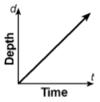
d.)
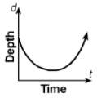

Keisha left home to walk two blocks to the school bus stop. After walking one block, she realized that she had left her soccer uniform at home. She ran home to get it and ran back to catch the bus. She only waited for one minute for the bus to arrive, then she rode the rest of the way to school. The graph of which function below correctly depicts this situation?

a.)
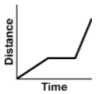
b.)
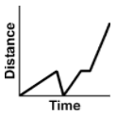
c.)
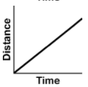
d.)
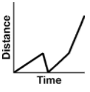

The graph below indicates Juanita’s distance from home as she travels to school.
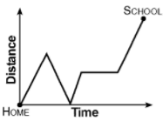
Which of the following best describes Juanita’s journey to school?
a.) She leaves for school, stops to play with a puppy, continues on her way, stops at the market o buy a bottle of juice, and arrives at school.
b.) She runs out the door, slows down to pick up a dollar, starts running again, stops to buy some candy, and runs to school.
c.) She leaves for school, returns home to retrived a homework assignments, leaves for school again, waits for a train to pass, and arrives at school.
d.) She dashes out the door, slows her pace down, starts skipping, jogs at a steady pace, and sprints to school.

Mr. Adams drove his son up Rte. 11W to track practice. After watching practice for awhile, he went farther up Rte. 11W to the supermarket to buy groceries. When he returned to pick up his son, practice was nearly over, so he waited briefly, and they drove home. The graph of which function below correctly depicts this situation?

a.)
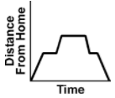
b.)
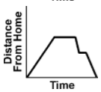
c.)
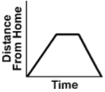
d.)
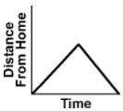

In the story about the race between the tortoise and the hare, the tortoise moves at a very slow constant rate from start to finish. The hare, however, starts out very fast and is so far ahead that he decides to stop and take a nap. When he wakes up, the tortoise has passed him. He runs to catch up, but the tortoise crosses the finish line just ahead of the hare. The graph of which function below correctly depicts this race between the tortoise and the hare?
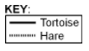
a.)
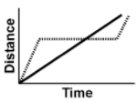
b.)
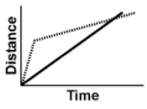
c.)
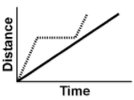
d.)
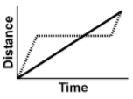
The graph below indicates the speed of a toboggan (snow sled) as it travels away from the house.
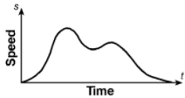
Which of the following statements best describes the relationship between speed and time?
a.) There is not enough information given.
b.) The toboggan (sled) is pulled up to the top of a steep hill, is ridden down the other side until it hits a small valley, goes over a small slope and speeds down the other side until it coasts to a stop.
c.) The toboggan (sled) moves farther away from the house, moves back toward the house, then farther away again, and approaches the starting point.
d.) The toboggan (sled) starts out slowly and picks up speed as it moves down a hill, slows when going up a small slope, and picks up speed down the other side before coasting to a stop.

