Unit 5 Lesson 11 – Interpreting Graphs of Functions

1.) Read through each of the scenarios, and choose the graph of the function that best matches the situation. Explain the reason behind each choice.

a.) The tire pressure on Regina’s car remains at $30$psi.
b.) Carlita inflates her tire at a constant rate for $4$ minutes.
c.) Air is leaking from Courtney’s tire at a constant rate.
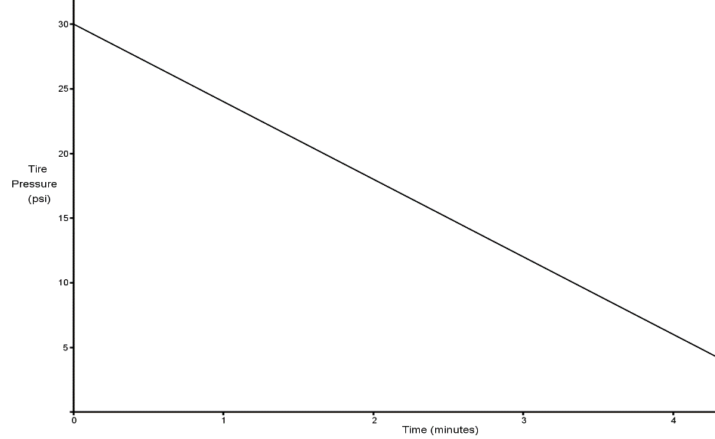 | Scenario:  Explanation:
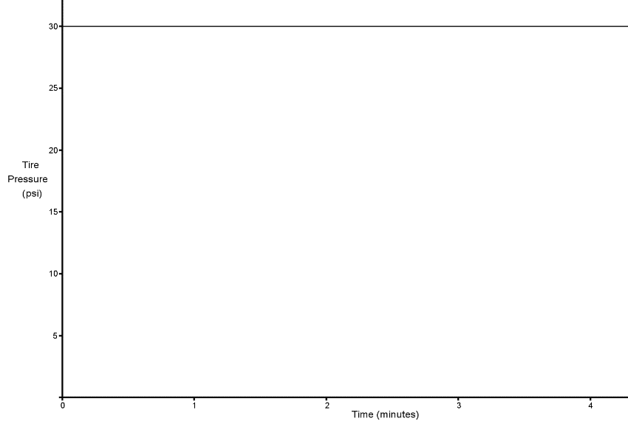 | Scenario:  Explanation:
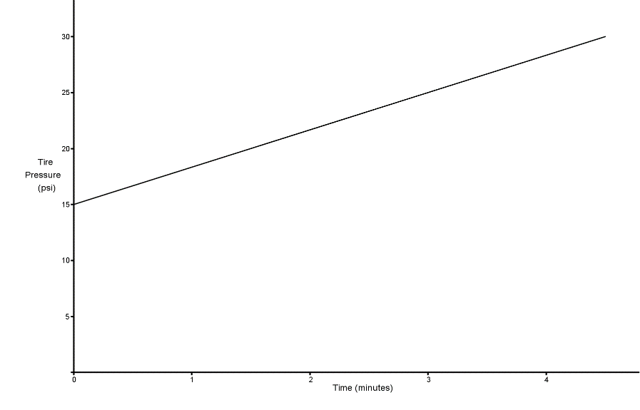 | Scenario:  Explanation:

2.) Read through the following scenarios and match each to its graph. Explain your reasoning.
A: This shows the change in a smartphone battery charge as a person uses the phone more frequently.
B: A child takes a ride on a swing.
C: A savings account earns simple interest at a constant rate.
D: A baseball has been hit at a little league game.
Scenario: | Scenario:  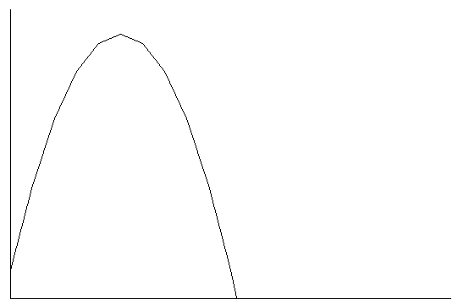
Explanation: | Explanation:
Scenario:  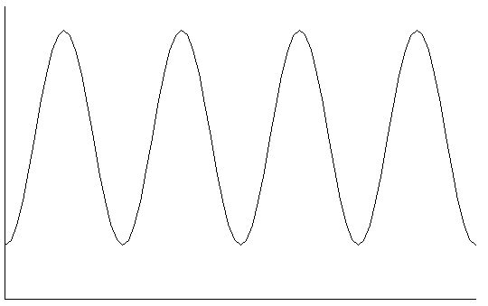 | Scenario:  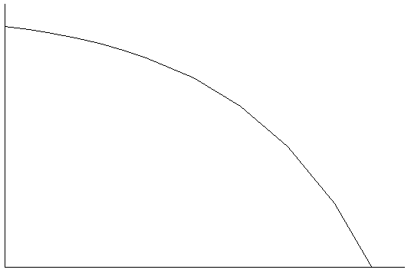
Explanation: | Explanation:

3.) The graph below displays the first hour of Sam’s bike ride. Match each part of the graph (A, B, and C) to its verbal description. Explain the reasoning behind your choice.

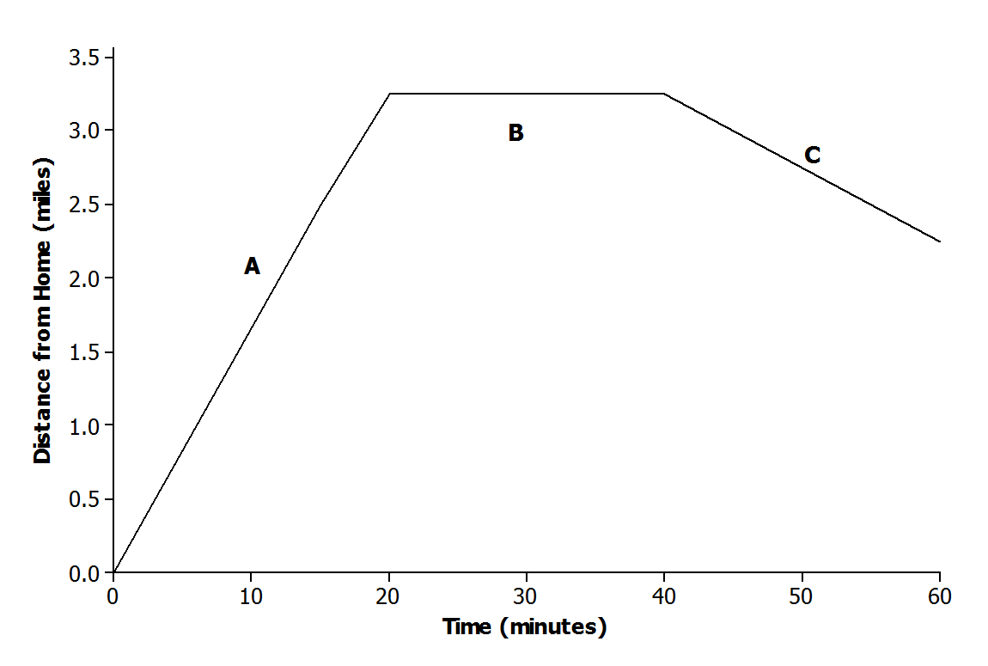

i. Sam rides his bike to his friend’s house at a constant rate.

ii. Sam and his friend bike together to an ice cream shop that is between their houses.

iii. Sam plays at his friend’s house.

4.) Anotinette has just hit a home run. Which of the following graphs best represents the relationship between her distance from the home plate and the length of time it takes her to completely run around the bases?

a.)
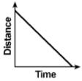
b.)
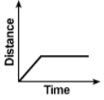
c.)
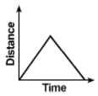
d.)
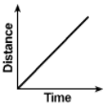

5.) Roy is playing on a swing is his backyard. Which of the following graphs best models the height (h) above ground when he is swinging and the amount of time (t) he spends swinging?

a.)
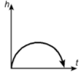
b.)
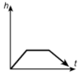
c.)
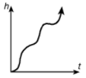
d.)
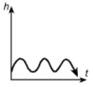

6.) The graph shows Miguel’s distance from school with respect to time.
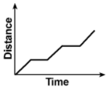
Which of the following statements best represents this graph?
a.) Miguel started driving to school, but he got stuck in a traffic jam and sat in the same spot until he gave up and returned home.
b.) Miguel’s speed varied between 10 mph and 30 mph depending upon the flow of traffic between his house and school.
c.) Miguel stopped once to talk to a friend on his cell phone on his way to the grocery store.
d.) Miguel had to stop at two red lights on his way to pick up his brother at soccer practice.
7.) On Wednesday, Andrew got up late so he had to run to get to school on time. After school, he walked home and stayed there several hours until he returned to school for a band concert. After the concert, he walked straight home. The graph of which function below correctly depicts this situation?

a.)
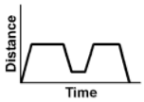
b.)
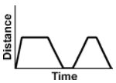
c.)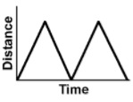d.)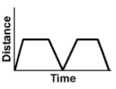

8.) Rentals for a certain movie were graphed on the chart below. Which of the following statements best describes the number of rentals over the number of weeks?

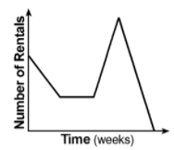

a.) Rental were constant over the time period.
b.) Sales started high, decreased and leveled off, sharply increased to a peak, and quickly dropped to zero.
c.) Rentals started at a maximum and decreased to zero.
d.) Rentals started high, decreased to a minimum, increased to a maximum, and fell to zero.

