Unit 5 Lesson 10 – Qualitative Features of Functions
1.) A home was purchased for $\$275,000$. Due to a recession, the value of the home fell at a constant rate over the next $5$ years. Sketch a graph of a function that models the situation.
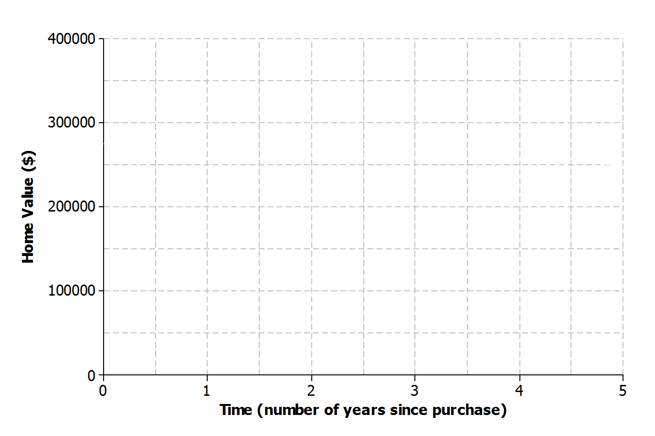

2.) Half-life is the time required for a quantity to fall to half of its value measured at the beginning of the time period. If there are $100$ grams of a radioactive element to begin with, there will be $50$grams after the first half-life, $25$ grams after the second half-life, and so on. Sketch a graph that represents the amount of the radioactive element left with respect to the number of half-lives that have passed.
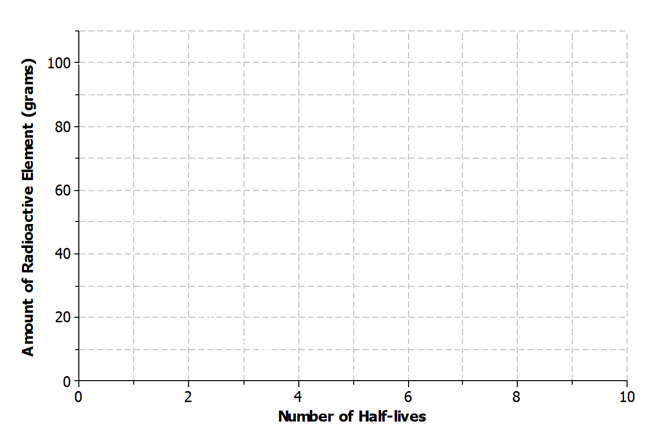

a.) Is the function represented by the graph linear or nonlinear? Explain.

b.) Is the function represented by the graph increasing or decreasing?

3.) Kern won a $\$50$ gift card to his favorite coffee shop. Every time he visits the shop, he purchases the same coffee drink. Sketch a graph of a function that can be used to represent the amount of money that remains on the gift card with respect to the number of drinks purchased.
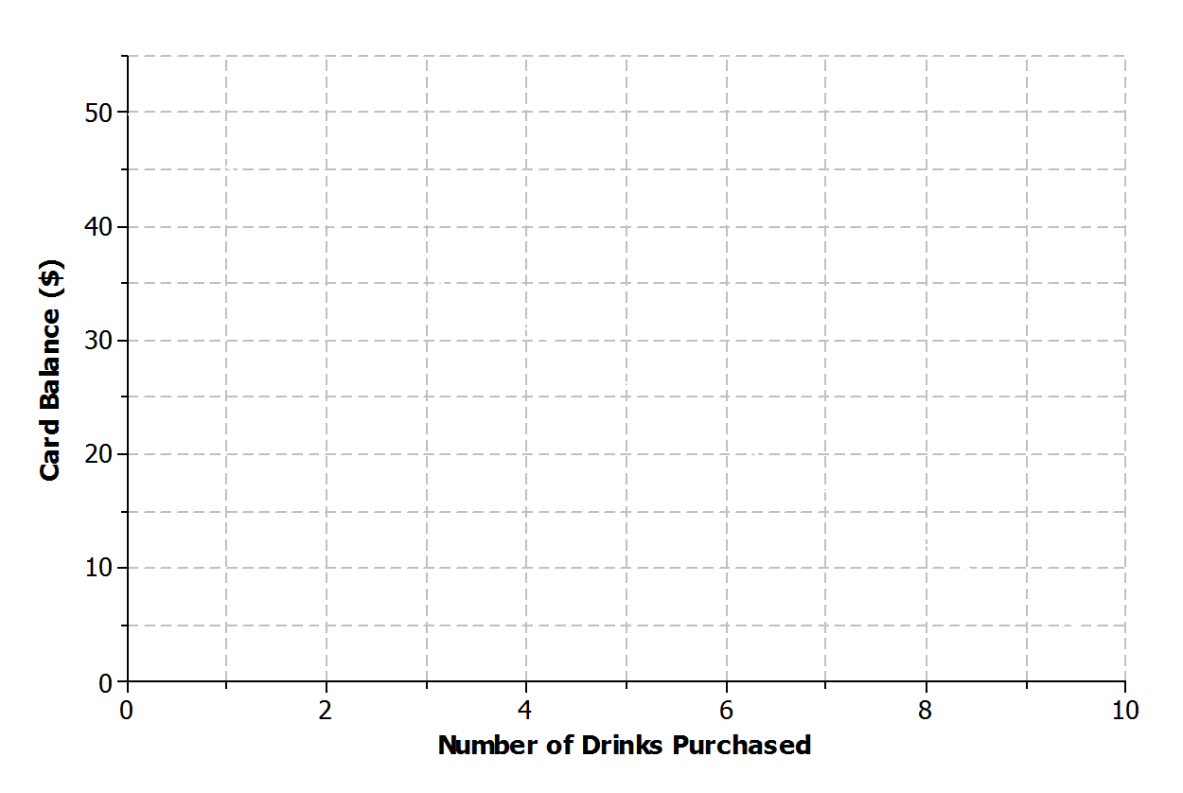
a.) Is the function represented by the graph linear or nonlinear? Explain.

b.) Is the function represented by the graph increasing or decreasing? Explain.

- Jay and Brooke are racing on bikes to a park $8$ miles away. The tables below display the total distance each person biked with respect to time. Which person’s distance can be modeled by a nonlinear function? Explain.
Jay  Time (minutes) Distance (miles)  $$0$$ $$0$$  $$5$$ $$0.84$$  $$10$$ $$1.86$$  $$15$$ $$3.00$$  $$20$$ $$4.27$$  $$25$$ $$5.67$$ | Brooke  Time (minutes) Distance (miles)  $$0$$ $$0$$  $$5$$ $$1.2$$  $$10$$ $$2.4$$  $$15$$ $$3.6$$  $$20$$ $$4.8$$  $$25$$ $$6.0$$

 | Determine whether each function is linear or non-linear and increasing or decreasing if linear. |  | Linear or Non-Linear |  | Increasing or Decreasing (if linear)
5.) | x 0 1 2 3 4  y 10 8 6 4 2
6.) | x 0 1 2 3 4  y 5 7 8 20 34
 |  | Determine whether each function is linear or non-linear and increasing or decreasing if linear. |  | Linear or Non-Linear |  | Increasing or Decreasing (if linear)
7.) |  | y = 6x + 5
8.) |  | f(x) = 1/2x + 3
9.) |  | y = 7 – 2x
10.) |  | f(x) = 2x² + 3x + 6

11.) Sketch a graph of a linear function that is always decreasing.
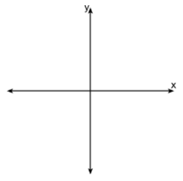
12.) Sketch a graph of a non-linear function that is increasing for all values of x.

13.) Sketch a graph of a function that is increasing for all x < 0 and decreasing for all x > 0.
14.) Sketch a graph of a function that is constant for all x < 0 and increasing for all
x > 0.

