Unit 3 Lesson 9 – AA Criterion for Similarity
Determine whether each pair of triangles is similar or not. Show your work and explain.
1.)
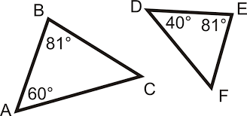

2.)
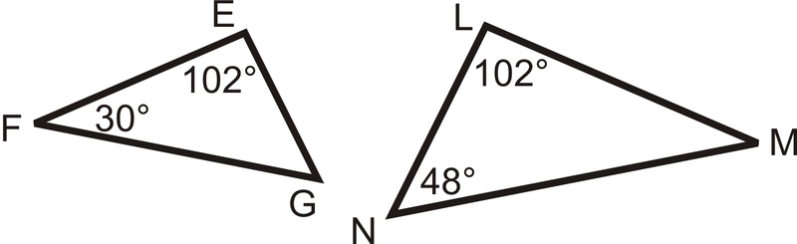

3.)
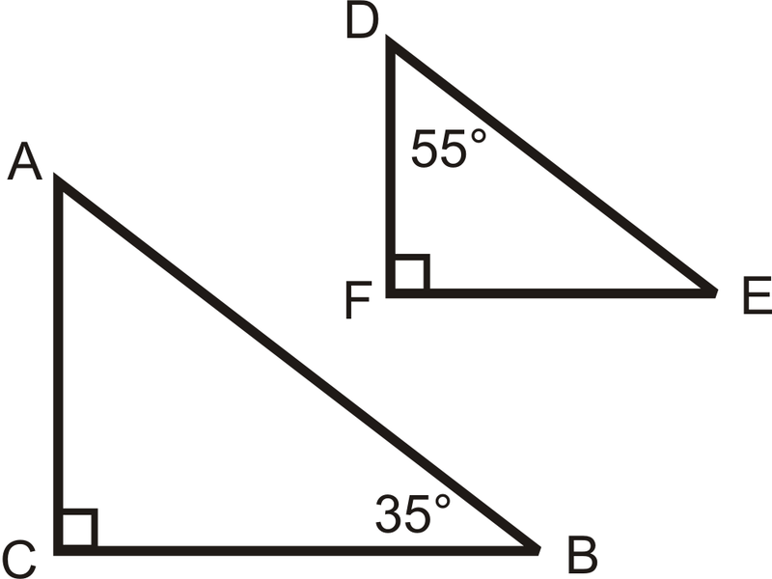
4.)
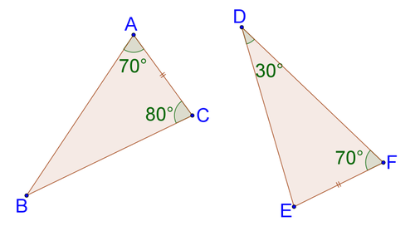
5.)
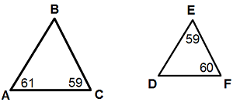

6.) Which triangles, if any, are similar below? Show your work.
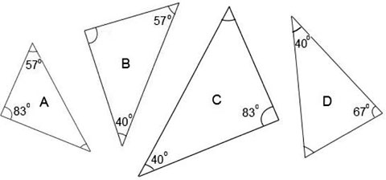
Determine whether each pair of triangles is similar or not. Show your work and explain.
7.)
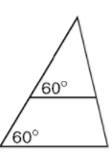

8.)
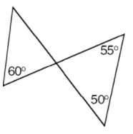

9.)
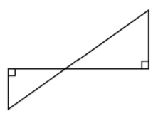

10.) In $∆$ PQR, m < P = 50º and m < Q = 30º and in $∆$ STV, m < S = 50º and m < T = 40º.

11.) In $∆$ PQR, m < P = 80º and m < Q = 25º and in $∆$ STV, m < S = 80º and m < T = 45º.

12.) In $∆$ ABC, m < A = 140º and m < B = 30º and in $∆$ DEF, m < D = 10º and m < E = 140º.

