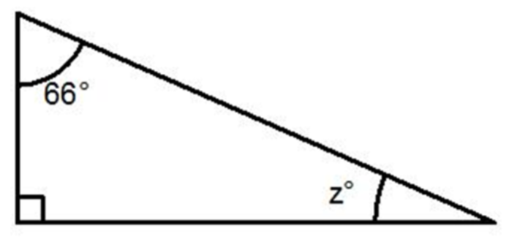
27º
AA Criterion for Similarity: Two triangles are similar if they have all of the same angle measures.

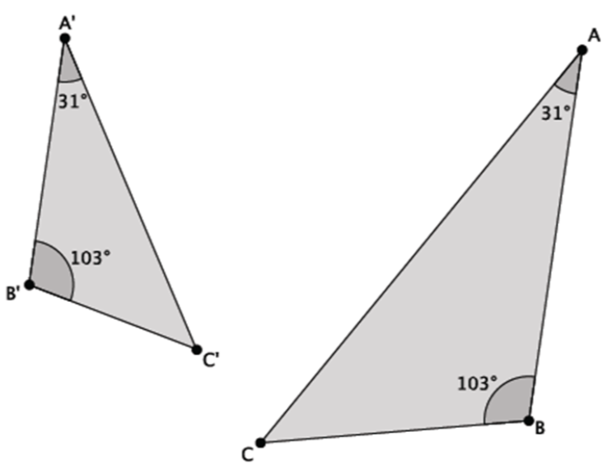
Yes they are similar. Both triangles have angles of 31º, 46º and 103º.

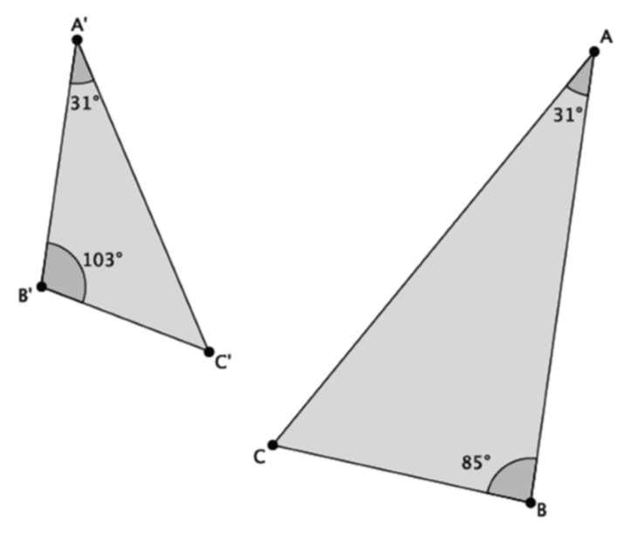
No they are not similar. The angles in the first triangle are 31º, 46º and 103º. There is an 85º angle in the second triangle.
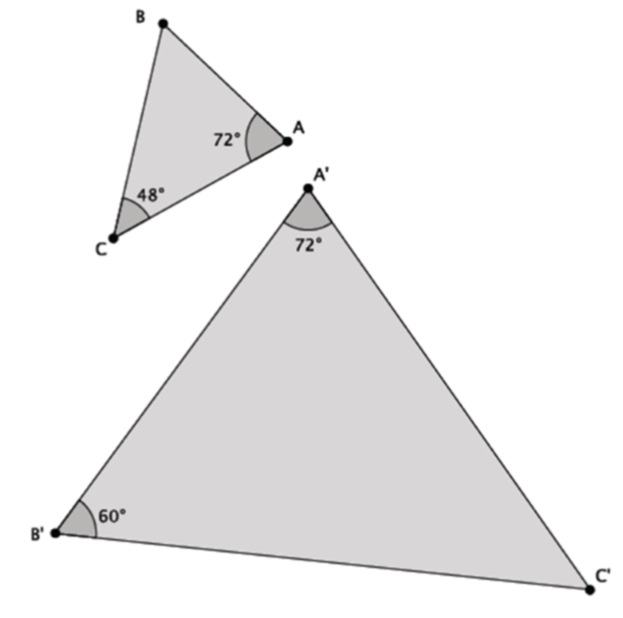
Yes they are similar. Both triangles have angles of 48º, 60º and 72º.

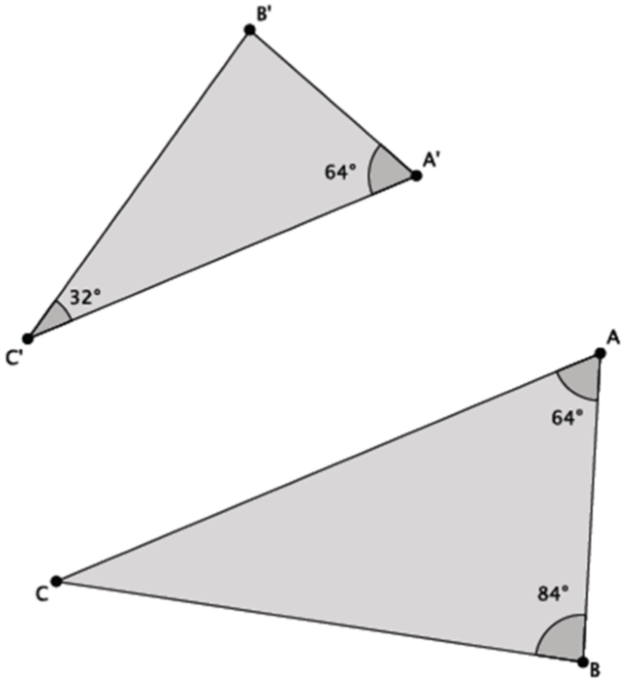
Yes they are similar. Both triangles have angles of 32º, 64º and 84º.
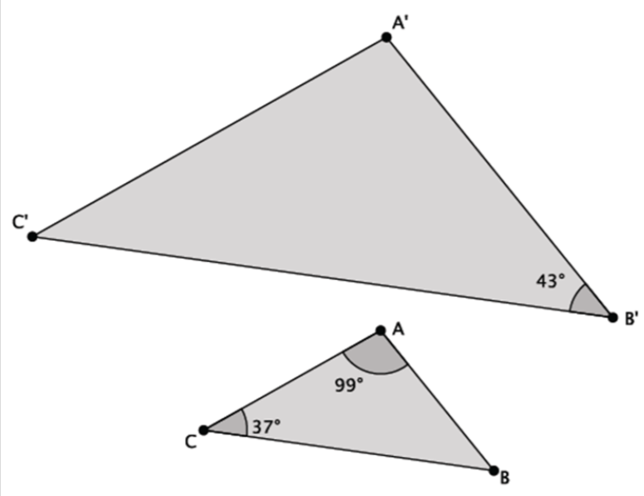
No they are not similar. The angles in the second triangle are 37º, 44º and 99º and the first triangle has a 43º angle.
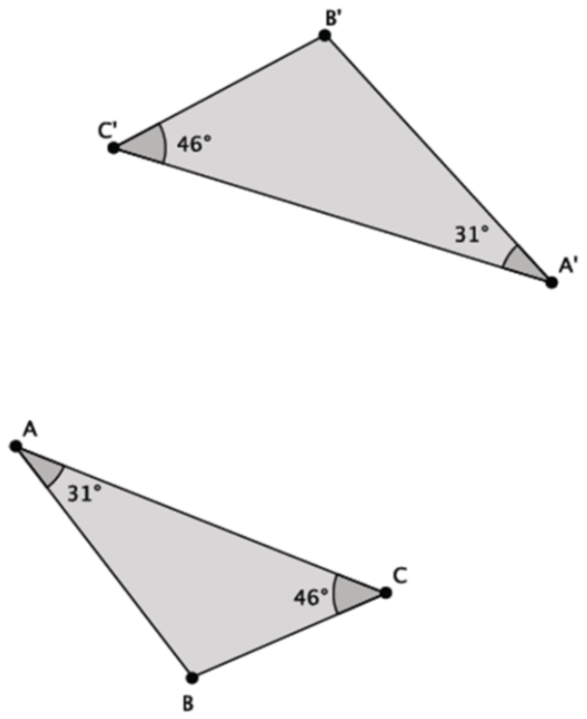
Yes they are similar. Both triangles have angles of 31º, 46º and 103º.

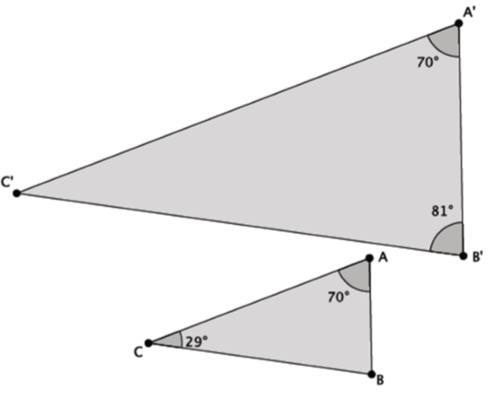
Yes they are similar. Both triangles have angles of 29º, 70º and 81º.

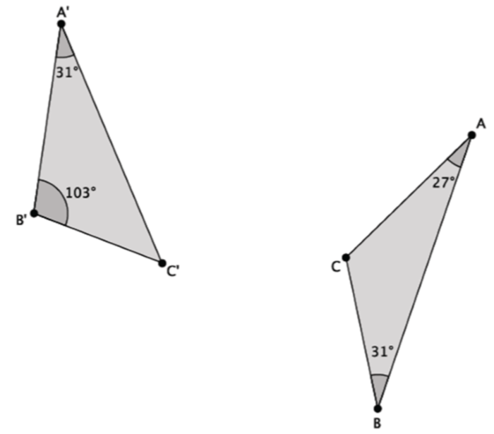
No they are not similar. The angles in the first triangle are 31º, 46º and 103º and the angles in the second triangle are 27º, 31º and 122º.

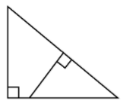
Yes they are similar. Both triangles have the same angle measure on the bottom right angle and a 90º angle so the third angle must have the same measure too.
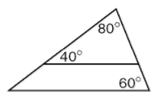
Yes they are similar. Both triangles have angles of 40º, 60º and 80º.
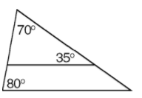
No they are not similar. The smaller triangle has angle measures of 35º, 70º and 75º and there is an 80º angle in the larger triangle.
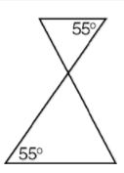
Yes they are similar. Both triangles have a 55º angle and the vertical angles would have the same measure so the third angles would have the same measure too.

In $∆$ ABC, m < A = 55º and m < B = 60º and in $∆$ DEF, m < D = 55º and m < E = 65º.
Yes they are similar. m < C = 65º and m < F = 60º so all of the angles have the same measure.

In $∆$ PQR, m < P = 35º and m < Q = 65º and in $∆$ STV, m < S = 60º and m < T = 35º.
No they are not similar. m < R = 80º and m < V = 85º so the angles are not all the same.

In $∆$ ABC, m < A = 90º and m < B = 20º and in $∆$ DEF, m < D = 90º and m < E = 70º.
Yes they are similar. m < C = 70º and m < F = 20º so all of the angles have the same measure.

