Parallel Lines Cut by a Transversal
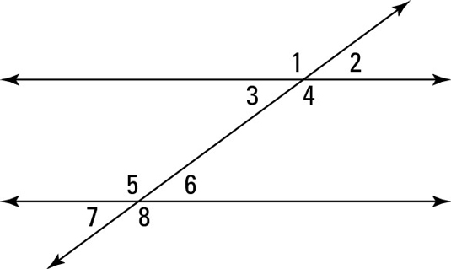
Corresponding Angles – Angles in matching corners.
1 & 5 2 & 6 3 & 7 4 & 8

Interior Angles – Angles inside of the parallel lines.
3, 4, 5 & 6

Exterior Angles – Angles outside of the parallel lines.
1, 2, 7 & 8

Alternate Interior Angles – Angles inside of the parallel lines on opposite sides of the transversal.
3 & 6 4 & 5

Alternate Exterior Angles – Angles outside of the parallel lines on opposite sides of the transversal.
1 & 8 2 & 7

If angle 3 is 42º, then what is the measure of angle 5?

138º

If angle 8 is 105º, then what is the measure of angle 1?

105º

If angle 6 is 27º, then what is the measure of angle 4?

153º

If angle 1 is 107º, then what is the angle of measure 5?

107º

If angle 4 is 123º, then what is the measure of angle 3?

57º

If angle 2 is 50º, then what is the measure of angle 6?

50º

