Unit 3 Lesson 5 – Parallel Lines Cut By a Transversal HW

Lines Q and R are parallel lines and are cut by the transversal Line P.
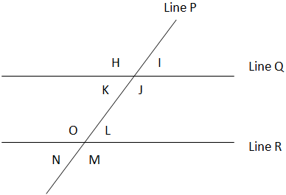
1.) Identify all pairs of corresponding angles.

2.) Identify all of the interior angles.

3.) Identify all of the exterior angles.

4.) Identify all pairs of alternate interior angles.

5.) Identify all pairs of alternate exterior angles.

6.) If the measure of angle K is 73º, then what is the measure of angle N?

7.) If the measure of angle J is 107º, then what is the measure of angle O?

8.) If the measure of angle H is 114º, then what is the measure of angle M?

9.) If the measure of angle O is 126º, then what is the measure of angle L?

10.) If the measure of angle I is 47º, then what is the measure of angle M?

