Unit 3 Lesson 4 – Angles

Find the missing angle(s) in each figure shown below.

1.)
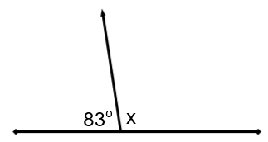

2.)

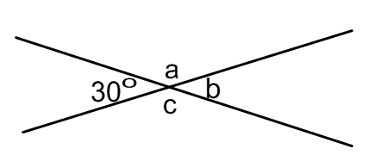

3.)
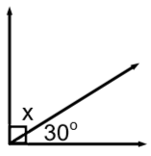
4.)
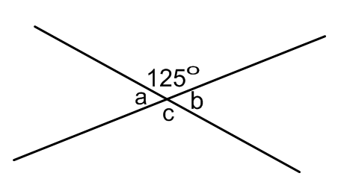
5.)
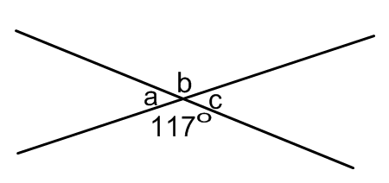
6.)
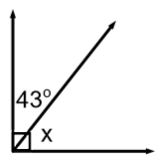
7.)
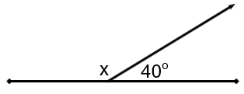

8.)
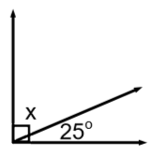

Which of the following pairs of angles are supplementary?
a.) 113º and 67º
b.) 180º and 180º
c.) 140º and 190º
d.) 76º and 14º
If angles A and B are complementary angles, then what else do we know?
a.) One angle is acute and one is obtuse.
b.) Both angles are acute angles.
c.) Both angles are right angles.
d.) Both angles are obtuse angles.

What are a pair of adjacent angles in the diagram below?
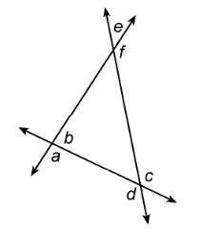
a.) a and d
b.) b and c
c.) c and d
d.) e and f

In the accompanying diagram, which of the following statements is true if $\overline{CD}$ ⊥ $\overline{AB}$?
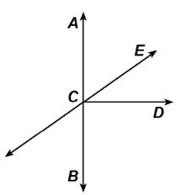
a.) ∠ ACE and ∠ ECD are complementary
b.) ∠ ACE and ∠ ECD are vertical angles
c.) ∠ ACE and ∠ ECD are supplementary
d.) ∠ ACE ≅ ∠ ECD

According to the given diagram, which of the following pairs of angles would have congruent measurements?
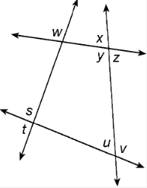
a.) ∠ s and ∠ u
b.) ∠ w and ∠ v
c.) ∠ x and ∠ y
d.) ∠ x and ∠ z
What are two supplementary angles in the given diagram?
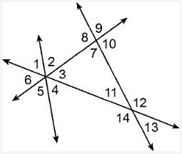
a.) 10 and 8
b.) 14 and 11
c.) 6 and 3
d.) 14 and 12

