Congruent – Have the same measure.
Complementary – Add up to 90º.

Supplementary – Add to 180º.

Adjacent – Two angles that share a side.

Vertical – When two lines cross, opposite angles are congruent.

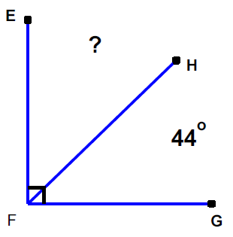
90 – 44 = 46º

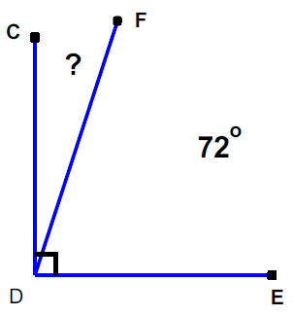
90 – 72 = 18º
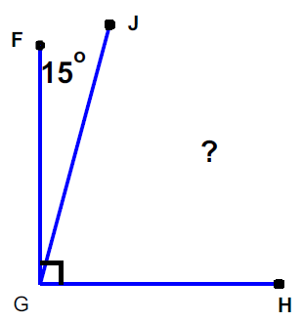
90 – 15 = 75º

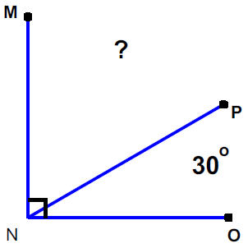
90 – 30 = 60º

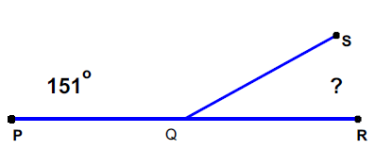
180 – 151 = 29º

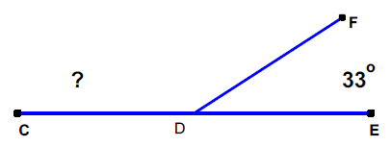
180 – 33 = 147º
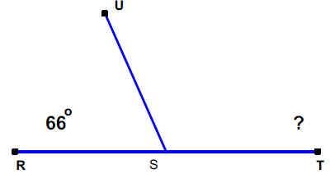
180 – 66 = 114º

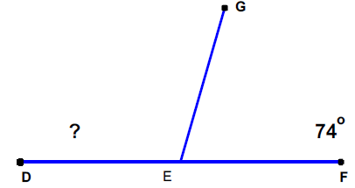
180 – 74 = 106º

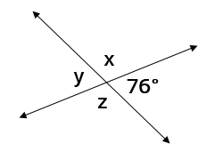
x = 104º y = 76º z = 104º

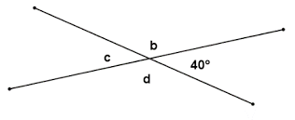
b = 140º c = 40º d = 140º
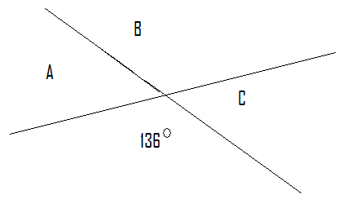
A = 44º B = 136º C = 44º

Find the complement to a 47º angle.
43º

Find the supplement to a 59º angle.
121º
Find the supplement to a 105º angle.
75º

Find the complement to a 72º angle.
18º

Which of the following pairs of angles are complementary?
a.) 45º and 47º
b.) 32º and 58º
c.) 90º and 90º
d.) 66º and 114º

Which of the following pairs of angles are supplementary?
a.) 37º and 43º
b.) 74º and 95º
c.) 28º and 152º
d.) 180º and 180º

If line l ⊥ line m, then which two angles are complementary?
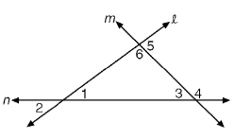
5 & 6

Name a pair of supplementary angles in the diagram shown below.
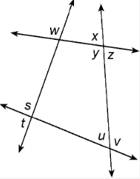
x & y y & z s & t u & v

Name a pair of vertical angles in the diagram shown below.
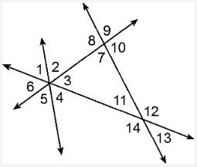
1 & 4 2 & 5 3 & 6 7 & 9

8 & 10 11 & 13 12 & 14

Name a pair of supplementary angles in the diagram shown below.
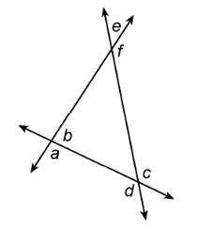
a & b

Use the diagram below to answer the following questions.
1.) Name a pair of vertical angles.
1 & 2 3 & 4

2.) Name a pair of supplementary angles.
3 & 4 5 & 6

3.) Name a pair of adjacent angles.
3 & 4 5 & 6

