Unit 3 Lesson 3 – Angle Measures in Polygons

1.) In a pentagon, each of two angles has a measure of 68º. Each of the other two angles measures 142º. What is the measure of the remaining angle?

2.) In a quadrilateral, one angle measures 175º. A second angle measures 29º, while a third angle measures 54º. What is the measure of the remaining angle?

3.) In a right triangle, there is a 57º angle. What is the measure of the third angle?

4.) In a hexagon, each of three angles has a measure of 83º. Two of the other angles each have a measure of 150º. What is the measure of the remaining angle?

Find the missing angle in each figure below.

5.)

6.)

7.)

8.)

9.)

10.)
<A = <C = <D =

11.)
<G = <H = <L =

12.)
<P = <R = <T =
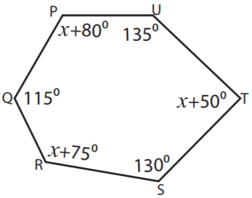

13.)
<A = <C = <F =

14.)
<H = <I = <K =

