Geometry Notation/Vocab

$$\overline{BC}$$ | Segment BC
∠ ABC or m ∠ ABC | Angle ABC
∆ ABC | Triangle ABC
|| | Is parallel to
⊥ | Is perpendicular to
≅ | Is congruent to
~ | Is similar to

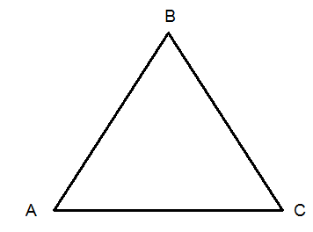
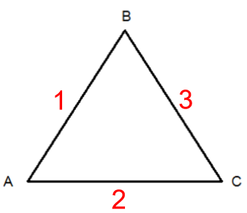
Mark off each side length with the given number.
1.) $\overline{AB}$

2.) $\overline{AC}$

3.) $\overline{BC}$

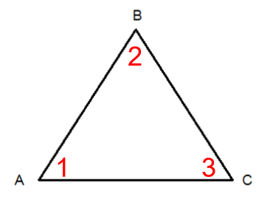
Mark off each angle with the given number.
1.) ∠ BAC

2.) ∠ ABC

3.) ∠ ACB

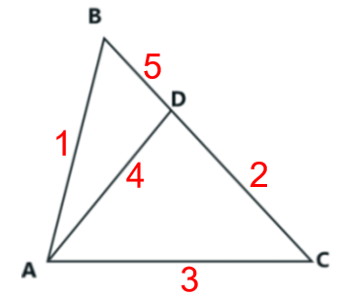
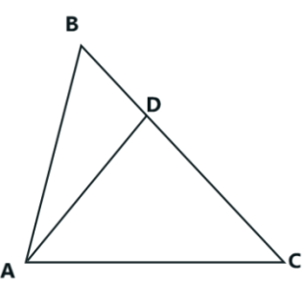
Mark off each side length with the given number.
1.) $\overline{AB}$
2.) $\overline{DC}$
3.) $\overline{CA}$
4.) $\overline{AD}$
5.) $\overline{BD}$

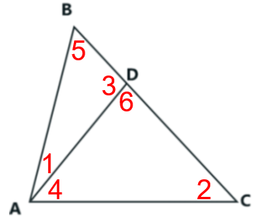
Mark off each angle with the given number.
1.) ∠ BAD
2.) ∠ ACD
3.) ∠ BDA
4.) ∠ DAC
5.) ∠ ABD
6.) ∠ ADC

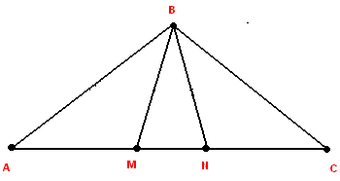
Mark off each side length with the given number.
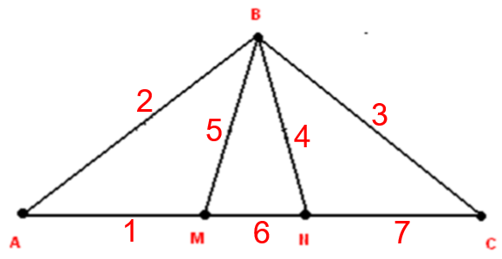
1.) $\overline{AM}$
2.) $\overline{AB}$
3.) $\overline{BC}$
4.) $\overline{BN}$
5.) $\overline{BM}$
6.) $\overline{MN}$
7.) $\overline{CN}$

Mark off each angle with the given number.
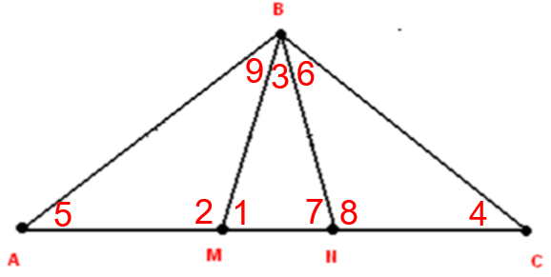
1.) ∠ BMN
2.) ∠ BMA
3.) ∠ BMA
4.) ∠ BCN
5.) ∠ BAM
6.) ∠ CBN
7.) ∠ BNM
8.) ∠ BNC
9.) ∠ ABM

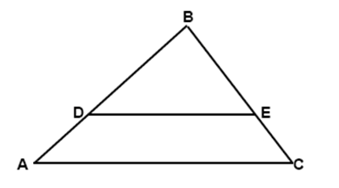
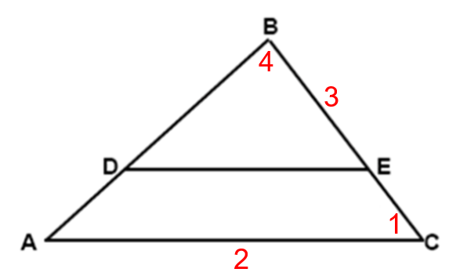
Mark off each angle and side with the given number.
1.) ∠ BCA
2.) $\overline{AC}$
3.) $\overline{BE}$
4.) ∠ DBE

Mark off each angle and side with the given number.

1.) ∠ ADP
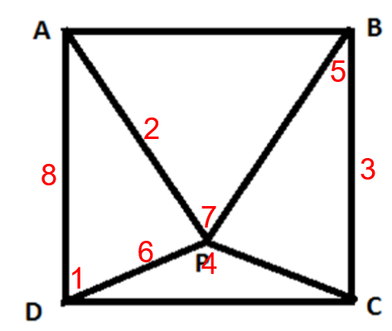
2.) $\overline{AP}$
3.) $\overline{BC}$
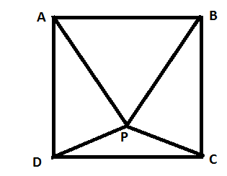
4.) ∠ DPC
5.) ∠ CBP
6.) $\overline{DP}$
7.) ∠ BPA
8.) $\overline{AD}$
$\overline{AB}$ ⊥ $\overline{CD}$
Line AB is perpendicular to line CD

∆ EFG ~ ∆ HIJ
Triangle EFG is similar to triangle HIJ

$\overline{KL}$ ⊥ $\overline{MN}$
Line KL is perpendicular to line MN

∠ O ≅ ∠ P
Angle O is congruent to angle P

$\overline{QR}$ || $\overline{ST}$
Line QR is perpendicular to line ST

∠ U = ∠ V
Angle U is equal to angle V

