Converse of the Pythagorean Theorem: If a² + b² = c², then a triangle is a right triangle.

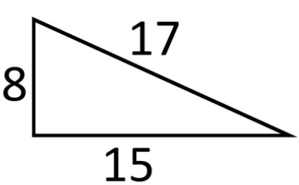
a² + b² = c²
8² + 15² ? 17²
64 + 225 ? 289
289 = 289
This is a right triangle.

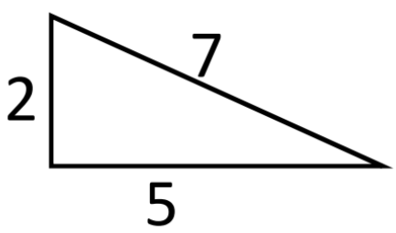
a² + b² = c²
2² + 5² ? 7²
4 + 25 ? 49
29 ≠ 49
This is not a right triangle.

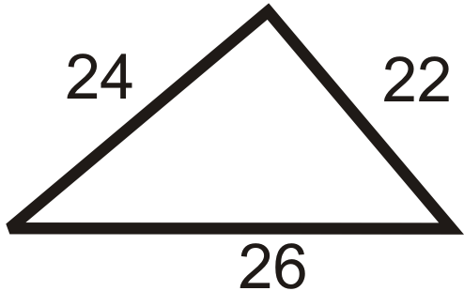

a² + b² = c²
22² + 24² ? 26²
484 + 576 ? 676
1060 ≠ 676
This is not a right triangle.

a = 12 ft
b = 16 ft
c = 25 ft

a² + b² = c²
12² + 16² ? 25²
144 + 256 ? 400
400 = 4400
This is a right triangle.

a = 12 km
b = 35 km
c = 37 km

a² + b² = c²
12² + 35² ? 37²
144 + 1225 ? 1369
1369 = 1369
This is a right triangle.

a = 20 ft
b = 21 ft
c = 30 ft

a² + b² = c²
20² + 21² ? 29²
400 + 441 ? 900
841 ≠ 900
This is not a right triangle.

