Unit 3 Lesson 14 – The Converse of the Pythagorean Theorem
For each of the problems below, the numbers in each diagram indicate the units of length of each side of the triangle. Is each triangle shown below a right triangle? Show your work.

1.)
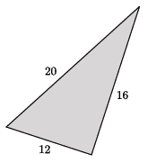

2.)
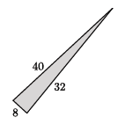

3.)
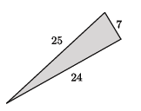

4.)
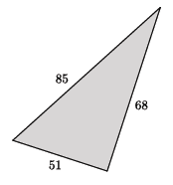

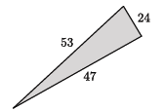
5.)

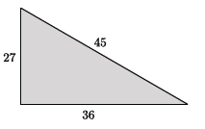
6.)

