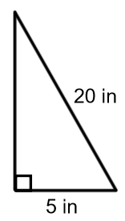
A right triangle has a hypotenuse with a length of 20 inches and a leg with a length of 5 inches. What is the length of the other leg?

a² + b² = c²
a² + 5² = 20²
a² + 25 = 400
a² = 375
a = 19.4 in

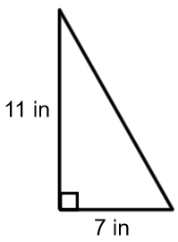
If a right triangle has a leg with a length of 11 inches and another leg with a length of 7 inches, then what is the length of the hypotenuse of the triangle?

a² + b² = c²
7² + 11² = c²
49 + 121 = c²
170 = c²
13 in = c

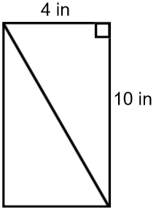
A rectangle has dimensions 4 inches by 10 inches. What is the length of the diagonal of the rectangle?

a² + b² = c²
4² + 10² = c²
16 + 100 = c²
116 = c²
10.8 in = c

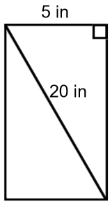
The diagonal of a rectangle is 20 in. The width is 5 in. What is the length of the rectangle?

a² + b² = c²
15² + b² = 25²
225 + b² = 625
b² = 400
b = 20 in

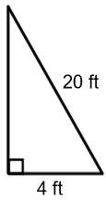
If a 20 foot ladder is placed so that the bottom of the ladder is 4 feet from the wall, then how far up the wall will the ladder reach?

a² + b² = c²
4² + b² = 20²
16 + b² = 400
b² = 384
b = 19.6 ft

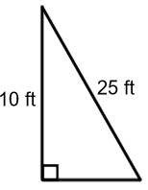
You have 25-foot ladder and need to reach exactly 10 feet up the wall. How far away from the wall should you place the ladder so that you can reach your desired location?

a² + b² = c²
10² + b² = 25²
100 + b² = 225
b² = 125
b = 11.2 ft

A rectangular soccer field is 80 meters wide and 100 meters long. If the coach asks the players to run from one corner to the corner diagonally across the field, then how far do the players run?
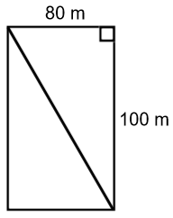
a² + b² = c²
80² + 100² = c²
6400 + 10000 = c²
16400 = c²
128.1 meters = c

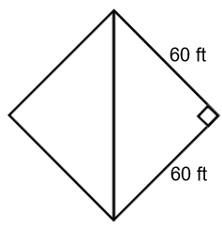
A softball diamond is a square that is 60 feet on each side. If a player throws the ball from 2nd base to home, then how far will the ball travel?

a² + b² = c²
60² + 60² = c²
3600 + 3600 = c²
7200 = c²
84.9 ft = c

