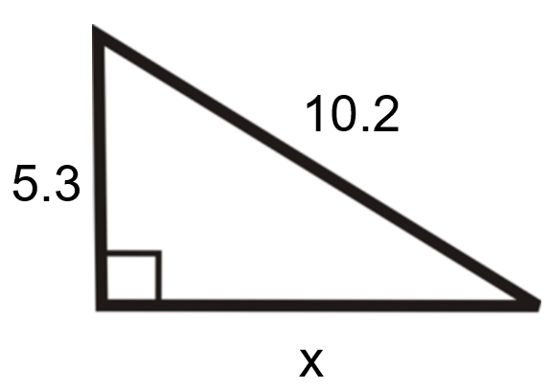
a² + b² = c²
a² + (5.3)² = (10.2)²
a² + 28.09 = 104.04
a² = 75.95
a = 8.7

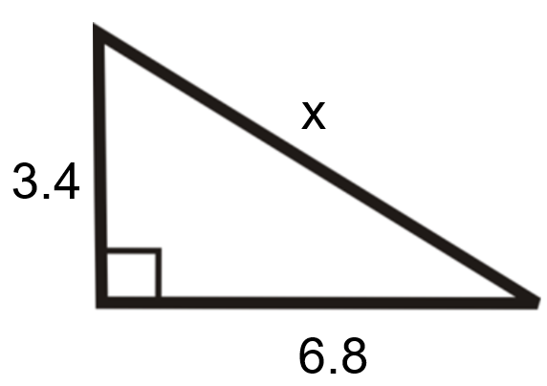
a² + b² = c²
(3.4)² + (6.8)² = c²
11.56 + 46.24 = c²
57.8 = c²
7.6 = c

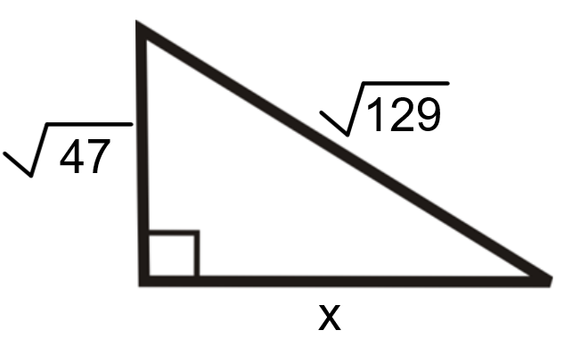
a² + b² = c²
${\left(\sqrt{47}\right)}^{2}$+ b² = ${\left(\sqrt{129}\right)}^{2}$
47 + b² = 129
b² = 82
b = 9.1

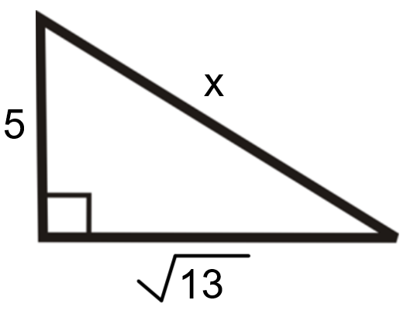
a² + b² = c²
5² + ${\left(\sqrt{13}\right)}^{2}$= c²
25 + 13 = c²
38 = c²
6.2 = c

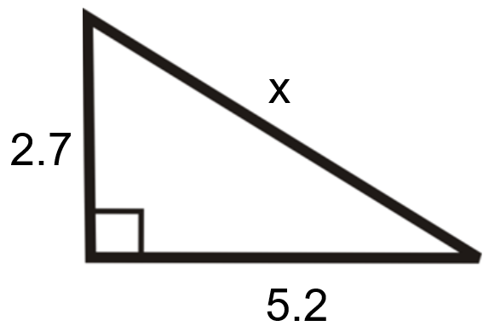
a² + b² = c²
(2.7)² + (5.2)² = c²
7.29 + 27.04 = c²
34.33 = c²
5.9 = c

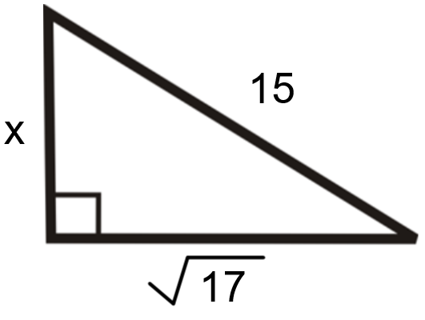

a² + b² = c²
a² + ${\left(\sqrt{17}\right)}^{2}$= 15²
a² + 17 = 225
a² = 208
a = 14.4

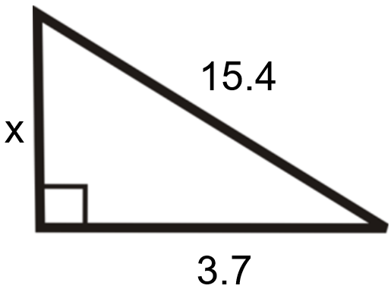
a² + b² = c²
a² + (3.7)² = (15.4)²
a² + 13.69 = 237.16
a² = 223.47
a = 14.9

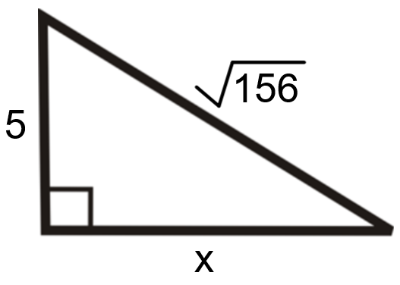
a² + b² = c²
5² + b² = ${\left(\sqrt{156}\right)}^{2}$
25 + b² = 156
b² = 131
b = 11.4

