SSS Criterion – Two triangles are similar if all 3 sides are proportional.
SAS Criterion – Two triangles are similar if they have one congruent angle and the 2 sides that form the angle are proportional.
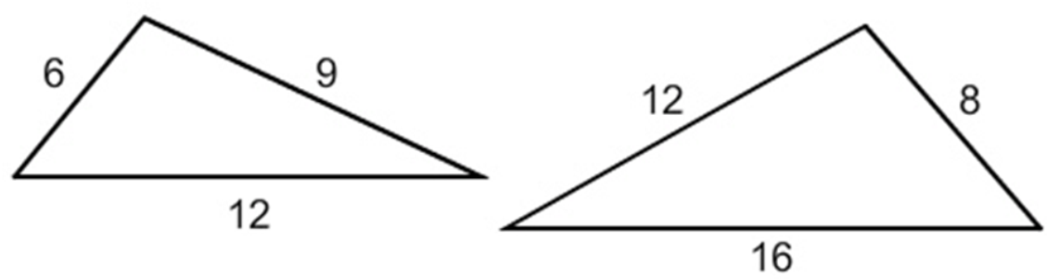
16 ÷ 12 = 1.333…
12 ÷ 9 = 1.333…
8 ÷ 6 = 1.333…
Yes these triangles are similar by SSS.
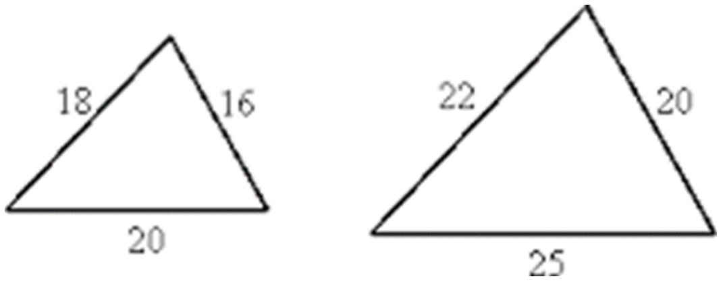
20 ÷ 16 = 1.25
22 ÷ 18 = 1.222…
25 ÷ 20 = 1.25
No these triangles are not similar because not all sides are proportional.
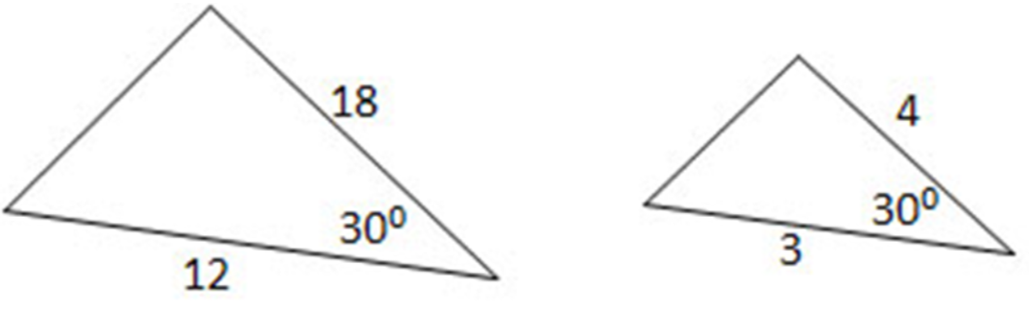
18 ÷ 4 = 4.5
12 ÷ 3 = 4
No these triangles are not similar because not all sides are proportional.
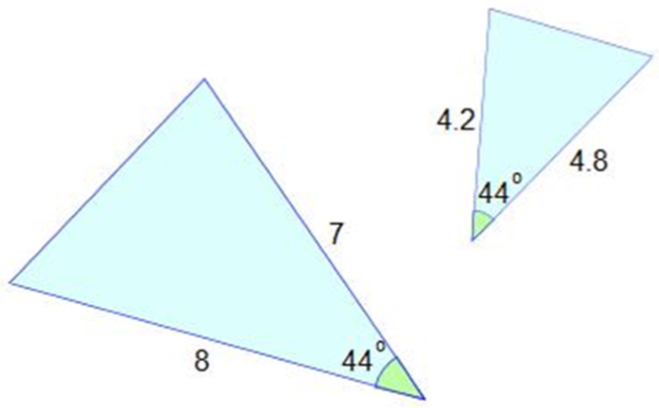
8 ÷ 4.8 = 1.666…
7 ÷ 4.2 = 1.666…
Yes these triangles are similar by SAS.

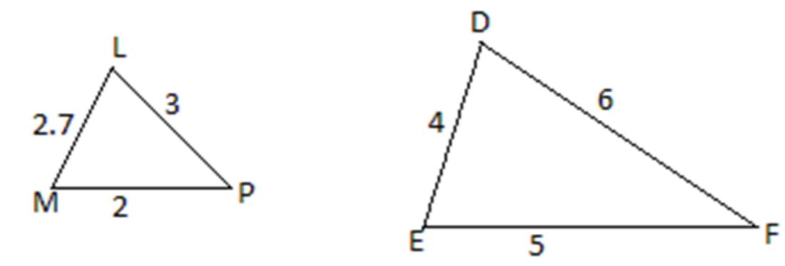
6 ÷ 3 = 2
5 ÷ 2.7 = 1.85
4 ÷ 2 = 2
No these triangles are not similar because not all sides are proportional.
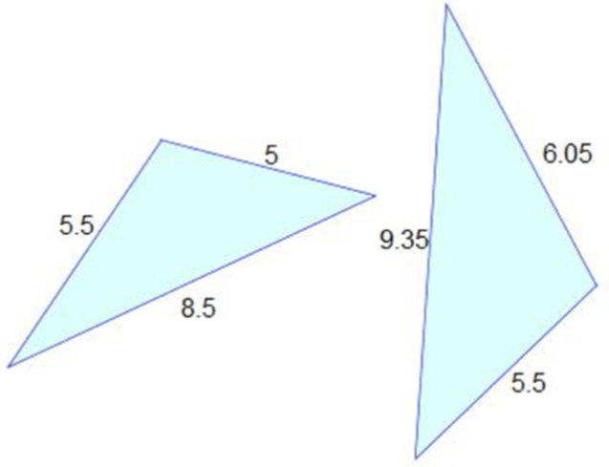
9.35 ÷ 8.5 = 1.1
6.05 ÷ 5.5 = 1.1
5.5 ÷ 5 = 1.1
Yes these triangles are similar by SSS.
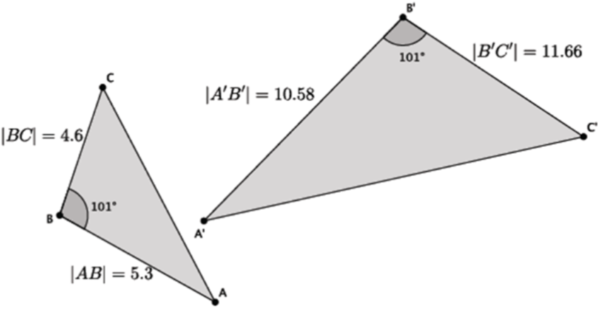
11.66 ÷ 4.6 = 2.5348…
10.58 ÷ 5.3 = 1.996…
No these triangles are not similar because not all sides are proportional.
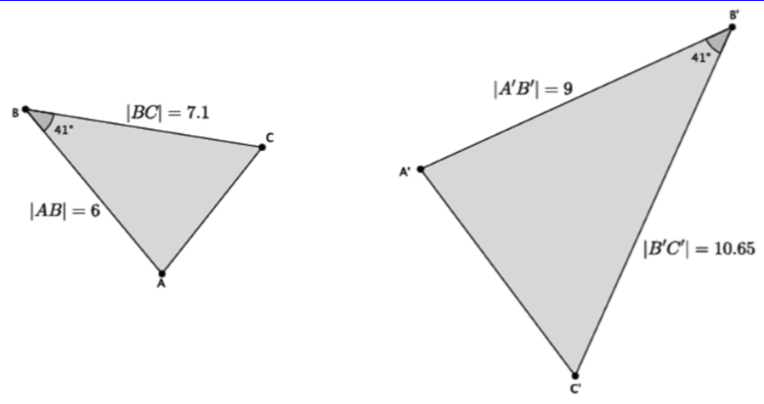
10.65 ÷ 7.1 = 1.5
9 ÷ 6 = 1.5
Yes these triangles are similar by SAS.
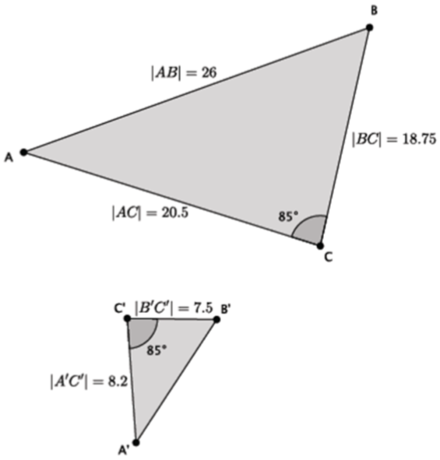
20.5 ÷ 8.2 = 2.5
18.75 ÷ 7.5 = 2.5
Yes these triangles are similar by SAS.

