Skills 5-1 Name:______________________________

Graph each of the following graphs on the coordinate grids below.

1.) $y=-\frac{1}{2}x+5$ 2.) $y=\frac{3}{2}x-4$
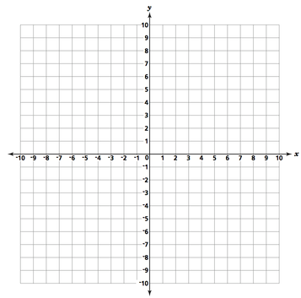
3.) $y=2x-3$ 4.) $y=-4x+7$

5.) Graph triangle ABC then dilate by k = ½.
A = (2, 4)
B = (2, 6)
C = (4, 4)
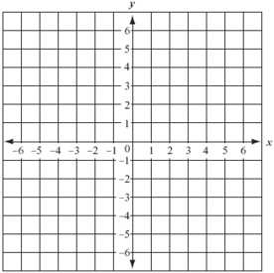

6.) Graph triangle DEF then translate (-2, 1).
D = (1, -2)
E = (3, -5)
F = (5, -4)

7.) Graph quadrilateral GHIJ then reflect over the x-axis.
G = (-7, -7)
H = (-6, -4)
I = (-4, -4)
J = (-3, -7)
8.) Graph quadrilateral KLMN then rotate 180º.
K = (-5, 5)
L = (-3, 5)
M = (-3, 3)
N = (-5, 3)

